Key Instant Recall Facts
Year 4 - Autumn term 2.
I can count in 7s.
I know multiplication and division facts for the 7 times tables.
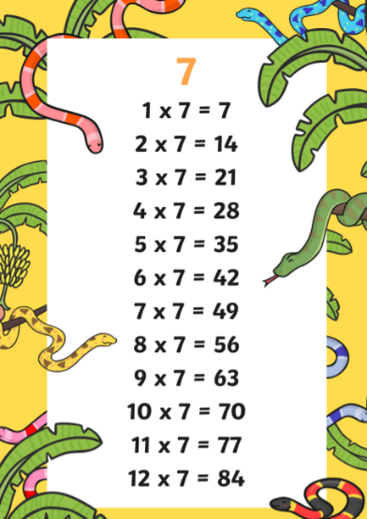
By the end of the term your child should know multiplication and division facts for the 7 times table.

Once your child is confident knowing the multiplication tables they can start to use this to do the divisions – for example “3 x 7 = 21 therefore 21 ÷ 3 = 7”

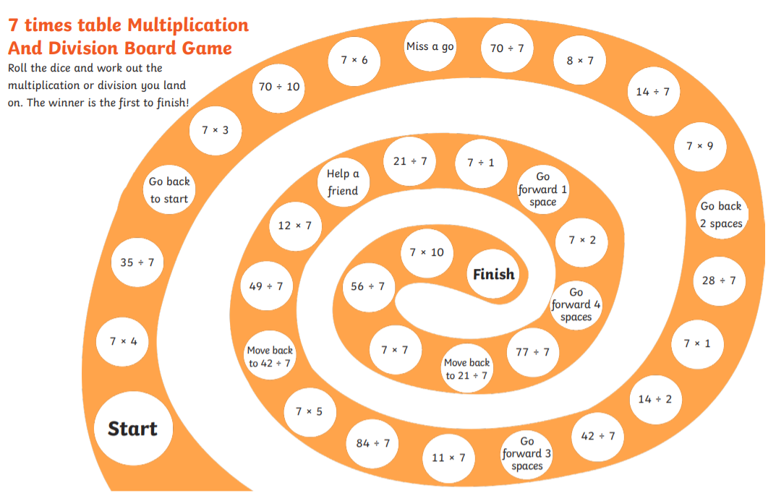
How you can help at home – remember that a little and often approach is best. Practise the 7 times tables in the car, on the way home from school, in the bath, waiting in a queue or whenever you have a spare moment.
Here is a game to play at home that will help you practise.

