Puffin Class Home-School Communication Sheet
Week beginning Monday 28th June 2021.
School Dinner Week 2

This week’s diary |  | It has been assessment week and Puffin Class have certainly shown resilience! Well done.  We have been outside in the sunshine with the cricket coaches this week, which the children really enjoyed.  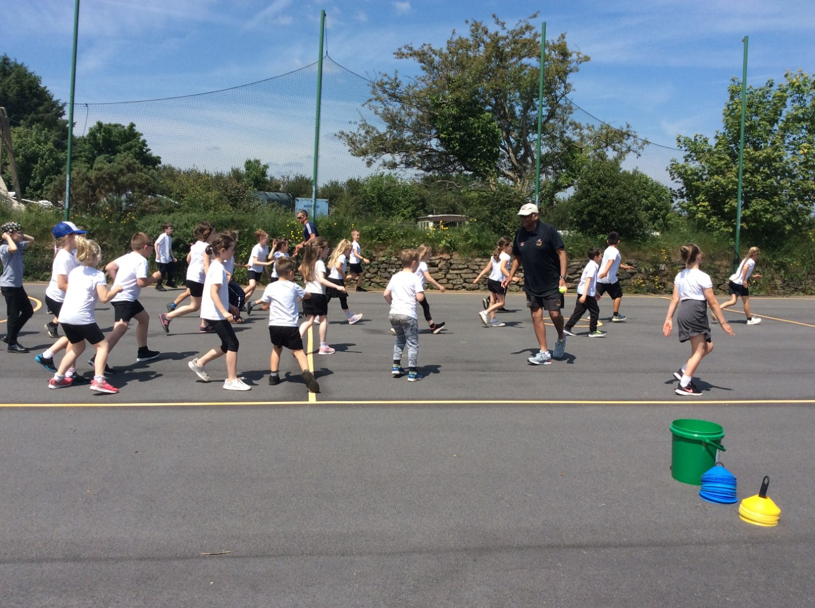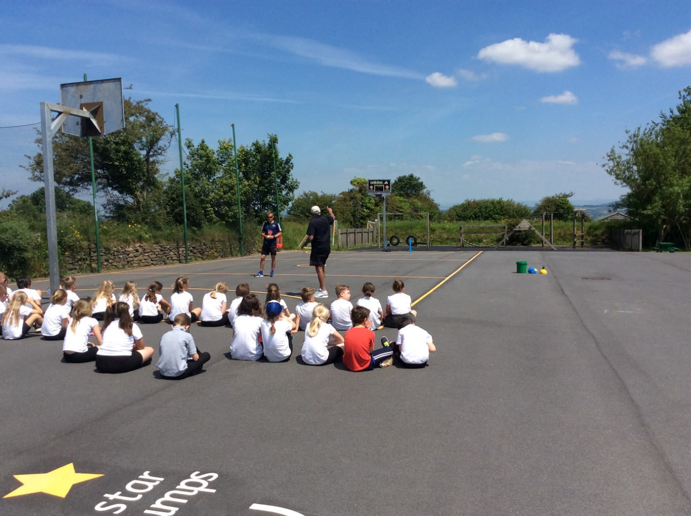  Sports Day is on Wednesday 30th June.  Wren Class 9:25am - 10:25am  Puffin Class 10:45am – 11:45am  Buzzard Class 1:30pm – 2:30pm  The children can come to school dressed in their PE kit. Please make sure your child has a sun hat, water bottle and is wearing sun cream. We look forward to your support on the day!  Homework has been set on mathletics.com and spag.com and logins for these sites are in the children’s reading records. We have also sent home all of the logins on a piece of card. Please make sure you also challenge yourself on Times Table Rockstars.  Spellings will be sent home on Monday to learn for a spelling test on Friday.
Monday | Mrs Palfrey  Library books
Tuesday | Mrs Palfrey  PE
Wednesday | Mrs Palfrey  PE with Mr Jones.  PPA Cover (p.m.) Mrs McDowell
Thursday | Mrs Palfrey
Friday | Mrs Palfrey  Spelling Test | Upcoming dates  - Sports day Wednesday 30th June
Other information
Please feel free to send me an email if you have any questions or concerns. bpalfrey@pensilva.cornwall.sch.uk
Do not forget the school website for information on school events, policies and newsletters. http://pensilva.eschools.co.uk/website or our Facebook page

