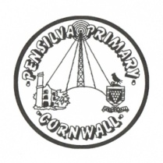
Wren’s Class Home-School Communication Sheet
Week beginning 24th May
School dinner week 1

This week’s diary |  | Hello Wrens.  This week we have been learning all about trees and we went on a tree hunt around the field. We also made fairy tale houses and the reception children all wrote a super sentence about their fairy house. The year 1s wrote instructions to how to build their fairy house.  Don’t forget to check out the school newsletters for photos and extra information about what the children have been up to each week.  This is the last week before half term so there is no school next week. The children will return to school on Monday 7th June.  From the 18th of June Miss King will be running a Lego club for all those reception and year 1 children who would love a bit of extra time to perfect their creations. The club will run from after school until 3.50. If you would like to sign up please email: secretary@pensilva.cornwall.sch.uk
Monday | Miss Thomas
Tuesday | Miss Thomas
Wednesday | Miss King  Mrs McDowell & PE with Mr Jones PM
Thursday | Miss King  PE with PAFC (PM)
Friday | Miss King | Upcoming dates:  Friday 28th May – Last day of term.  Friday 11th June – inset day – school closed for children  Monday 14th June – inset day – school closed for children.
Other information
Please feel free to send us an email if you have any questions or concerns: Jthomas@pensilva.cornwall.sch.uk lking@pensilva.cornwall.sch.uk
Do not forget the school website; http://pensilva.eschools.co.uk/website for information on school events, policies and newsletters or our Facebook page; Pensilva Primary School for updates.

