Thursday 7th January 2021
Warm Up Activity
Practice counting in 2s up to 20. Can you do this independently and with confidence?
Challenge (if confident): Can you do it backwards?

Main Task
Reasoning and problem Solving
Complete the following page of activities. It may help to talk through your ideas with your adult.
If you feel confident there is a challenge you can complete on the last page.

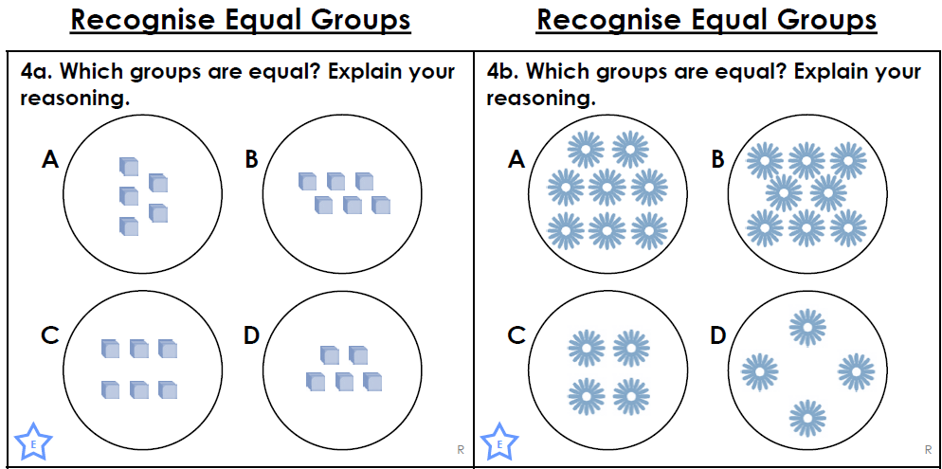
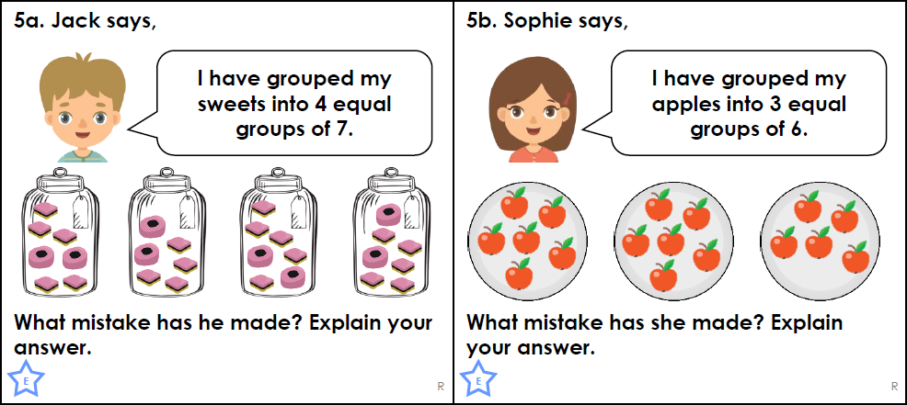
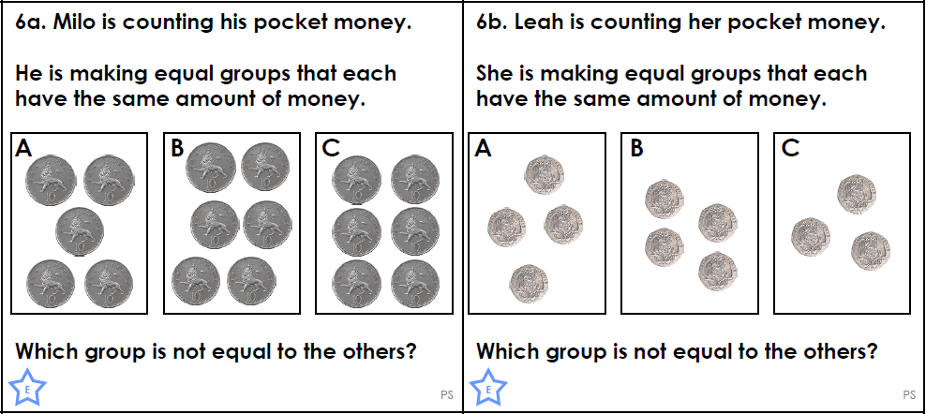

Optional Challenge…

