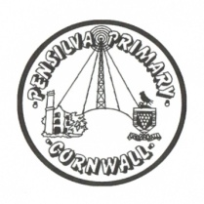
Wren’s Class Home-School Communication Sheet
Week beginning 13th September
School dinner: Week 3

This week’s diary |  | Wow Wrens! What a fantastic first week we have all had. The children have all settled so amazingly well and have done such a great job at working together to make the classroom a lovely and friendly place to be.  The children all visited the school library today and chose a book that they would like to share at home with you. These will be changed every week so please could the children keep them safe and return them to school by next Friday if they would like a new one.  As the children get underway with their Read Write Inc sessions (where we will be learning all our sounds and how to blend them to make words) they will also begin to bring home Read Write Inc books or ditty sheets to practise.  We are very aware of how strange these first few weeks feel for those parents and children in reception. If you have any concerns or questions over the coming weeks please feel free to email. We look forward to an amazing year together!
Monday | Miss Thomas  (Mrs McDowell PM)
Tuesday | Miss Thomas
Wednesday | Miss King
Thursday | Miss King  Mrs McDowell & PE with Mr Jones PM
Friday | Miss King | Upcoming dates:
Other information
Please feel free to send us an email if you have any questions or concerns: Jthomas@pensilva.cornwall.sch.uk lking@pensilva.cornwall.sch.uk
Do not forget the school website; http://pensilva.eschools.co.uk/website for information on school events, policies and newsletters or our Facebook page; Pensilva Primary School for updates.

