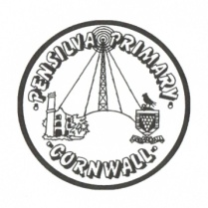
Wren’s Class Home-School Communication Sheet
Week beginning 8^{h} November
School dinner: Week 2

This week’s diary |  | Well done Wrens – you have worked very hard this week. We have been learning all about bonfire night and Guy Fawkes. We have also been learning about how to be safe around fireworks and fires.  On Monday 8th November the reception have their vision screening. This is a very quick test that is not stressful for the children. You will receive information about how your child has done, and whether they need any follow up appointments, on the same day.  The children have all been given their new KIRFs for the term this week. Please could these be practised at home – just a couple of minutes every day makes such a big difference over a half term.  Please also continue to support your child with their sounds. Again practising just a couple of sounds a night really supports your child in their learning journey.  Thank you all for your continued support.  Miss King and Miss Thomas
Monday | Miss Thomas  (Mrs McDowell PM)
Tuesday | Miss Thomas
Wednesday | Miss King
Thursday | Miss King  Mrs McDowell & PE with Mr Jones PM
Friday | Miss King | Upcoming dates:  November 19th – year 1 hearing screening.  November 19th – Children in need. Children can dress up on this day.
Other information
Please feel free to send us an email if you have any questions or concerns: Jthomas@pensilva.cornwall.sch.uk lking@pensilva.cornwall.sch.uk
Do not forget the school website; http://pensilva.eschools.co.uk/website for information on school events, policies and newsletters or our Facebook page; Pensilva Primary School for updates.

