Decorate an egg to look like your favourite endangered species!

What do you need?

- Free range eggs (one per student plus a few extras in case some crack)
- Decorating materials such as paint, felt, coloured card, pipe cleaners etc.
- Scissors
- Glue and/or sticky tape

Tip: Googly eyes are the perfect finishing touch!

a) Boiled egg method:

- Saucepan
- Spoon
- Bowl

b) Blown egg method:

- Darning needle
- Bowl
- Paper towel
- Sand (optional)

Summary:

For this hands-on, creative art activity, students select their favourite threatened species and use the ARKive website to study their chosen species’ key features. Students work individually to decorate their egg in the style of their chosen endangered species using the materials provided.

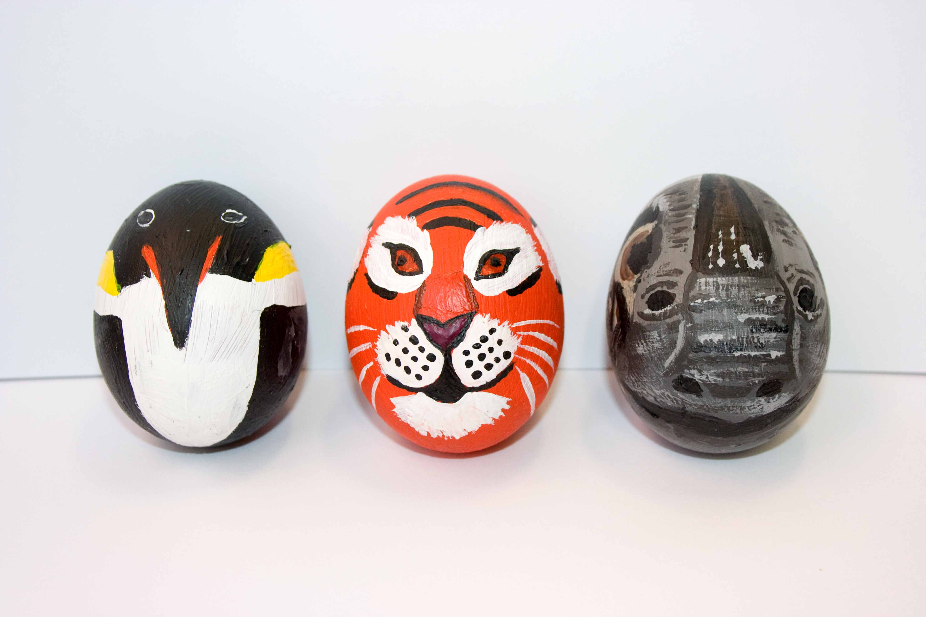
The eggs should either be hard boiled or blown to remove their contents and leave only the shell (see below for instructions). Hard boiled eggs are more robust and are therefore suitable for younger students to handle. However, remember that hard boiled eggs are perishable and blown eggs can be kept for a longer period of time.

Eggs can be decorated using paints, and coloured card could be cut out and attached to create wings, tails, manes etc. The egg could sit on a cut up tissue roll tube to form a body or legs. Pipe cleaners also make effective legs.

Students can present their decorated egg to the rest of the class, explaining why the species they chose is their favourite and why it is endangered.

Preparation guidelines:

- Prepare the eggs by either a) boiling or b) blowing (see instructions below). You may wish to prepare the eggs yourself although for older students, you could allow the students prepare their own eggs with supervision.
- Alternatively, you may wish to request for each of the students to prepare an egg with parental supervision at home and bring it into school ready to decorate.
- It may be helpful to decorate a couple of eggs in advance to provide ideas for the students

a) How to boil an egg

- Place eggs in a single layer in a saucepan and cover with water (without the pan lid on).
- Bring the water to the boil.
- Once the water is boiling, reduce the temperature and simmer the eggs for 10 minutes.
- After 10 minutes, take the pan off the heat (and turn off the hob).
- Carefully pour away the excess water from the pan and use a spoon to scoop the eggs from the saucepan into a bowl.
- Allow the eggs to cool naturally or run them under cold water.
- When the eggs are cool they are ready to decorate.
- If not decorating the eggs immediately, store them in a refrigerator.

b) How to blow out an egg
- Using a darning needle, carefully pierce a hole in the broader end of the egg.
- Break the yolk by passing the needle into the egg, and stir the contents.
- Carefully create a larger hole in the narrow end of the egg
- By blowing into the small hole, force the contents out of the eggshell and into the bowl
- Clean the eggshell well by running warm water through the large hole. Cover both of the holes with your fingers and gently shake to loosen any remaining material
- Leave the egg to drain on paper towel
- Once the egg has dried, it is ready to decorate
- The dry eggshell will be very delicate. Filling it with sand may help make it easier to handle.
Possible species to try:

Giant panda Tiger Asian elephant
Bornean orangutan Black rhinoceros Hyacinth macaw
Hawksbill turtle Great hammerhead Amur leopard
Mediterranean monk seal Philippine eagle Kakapo
Western gorilla Lion Great white shark
Safety notes:
- Discard any eggs that have cracked during boiling and do not decorate.
- Make sure students wash their hands often while decorating the eggs and thoroughly once they have finished.
- Students must be supervised at all times when dealing with boiling water.

Here are some examples made by the ARKive team!
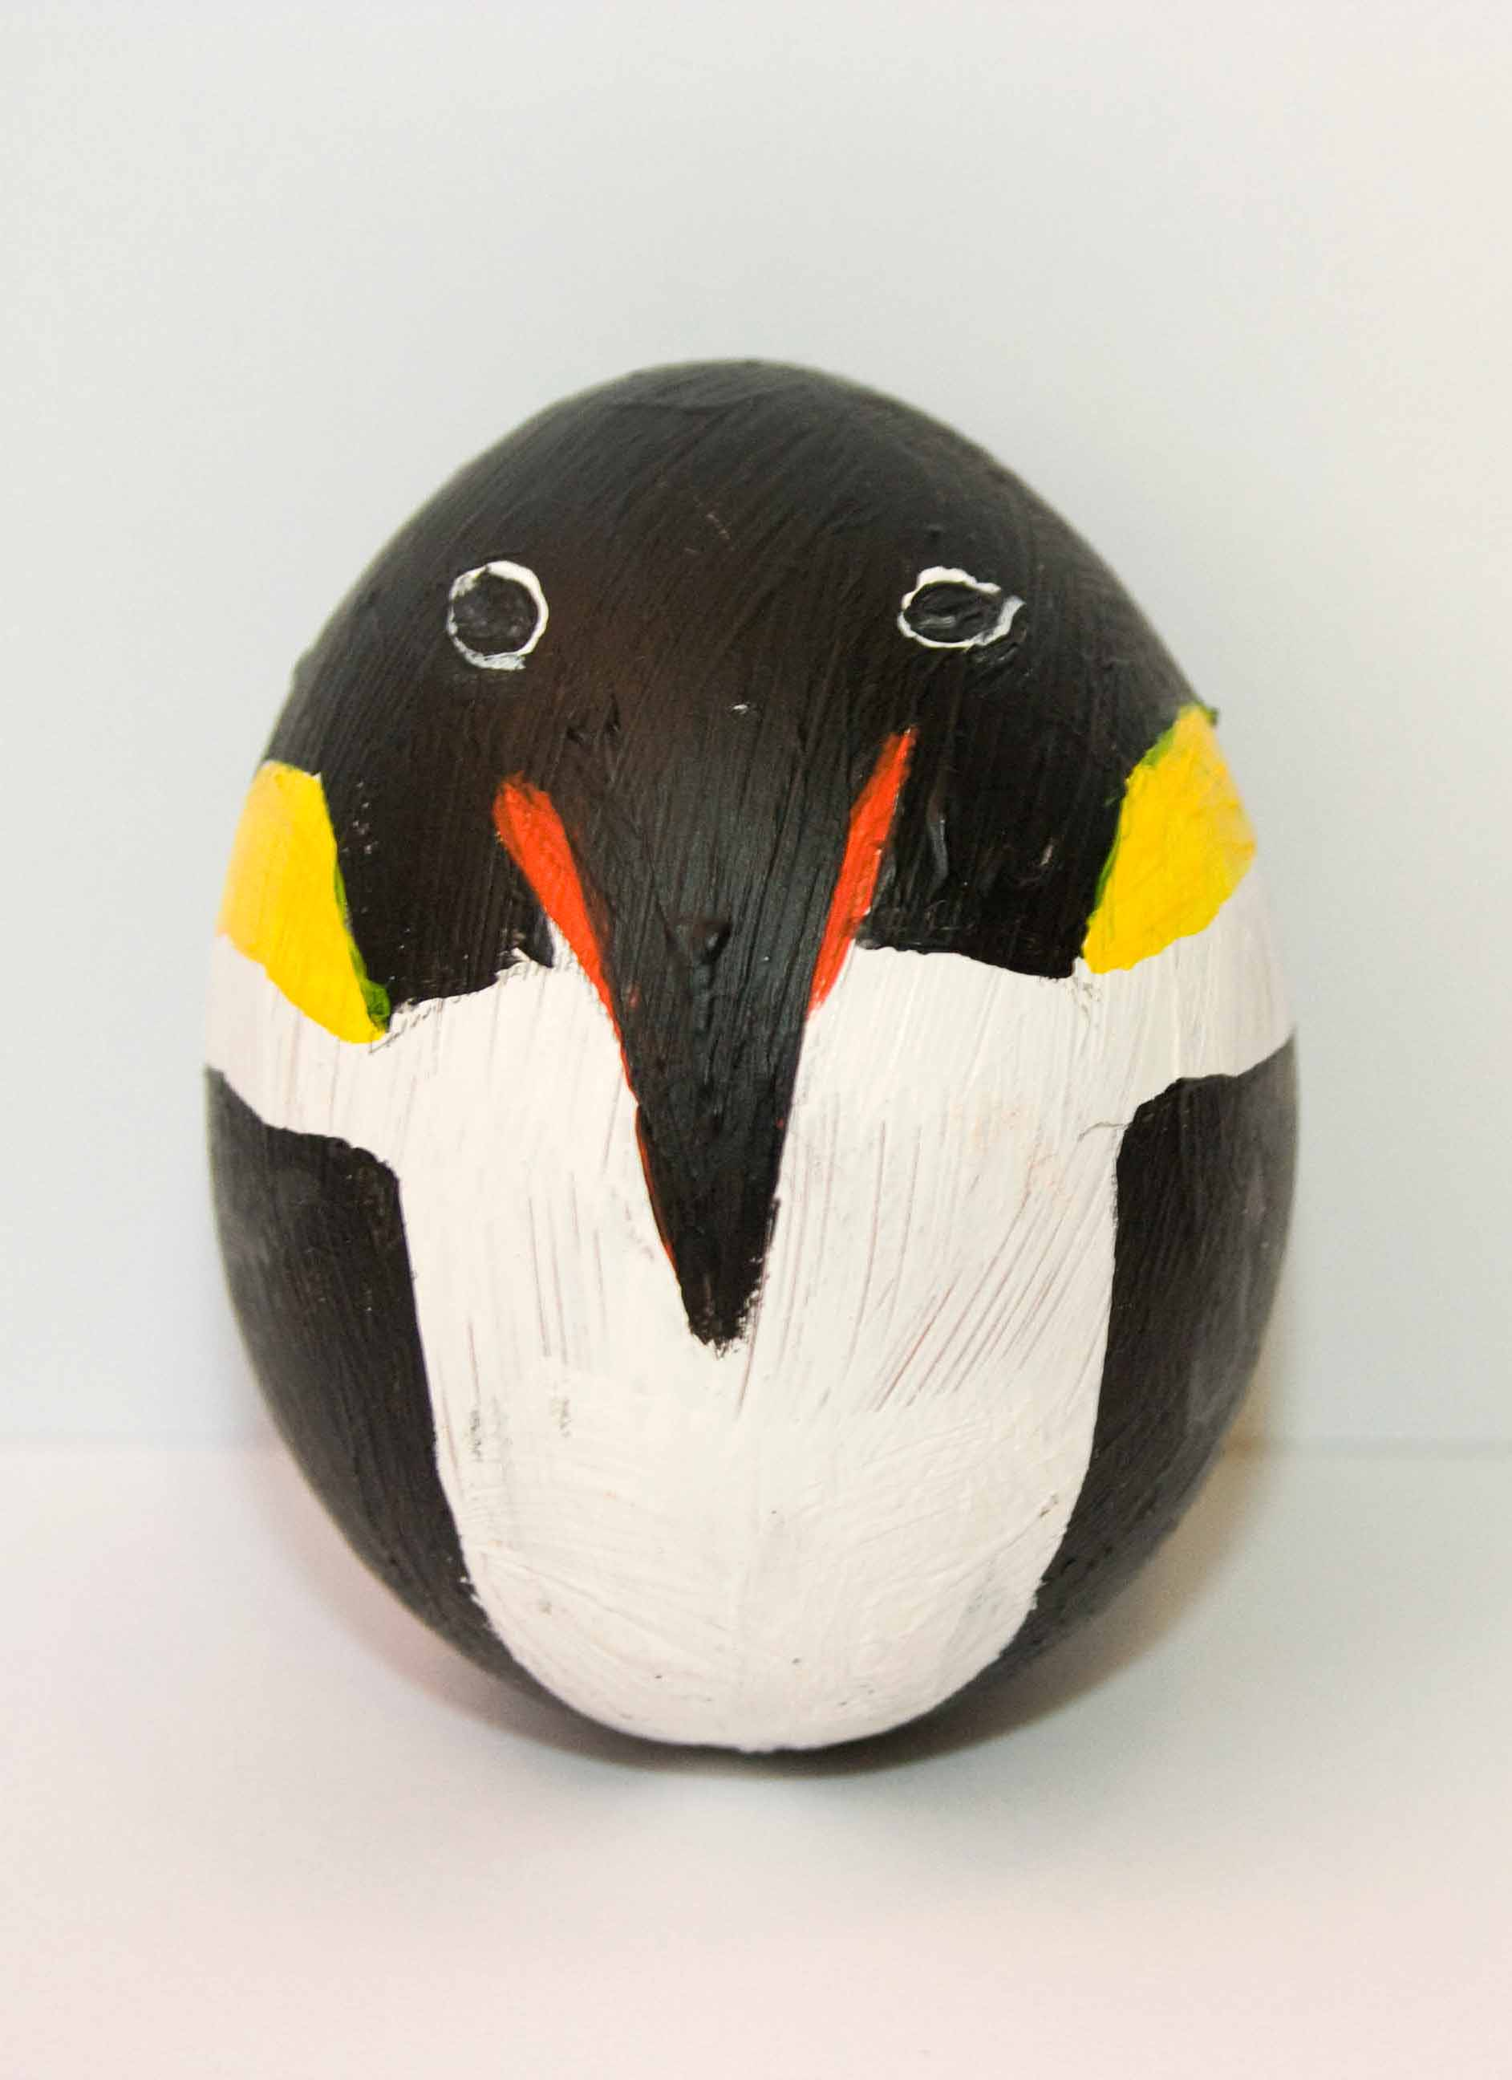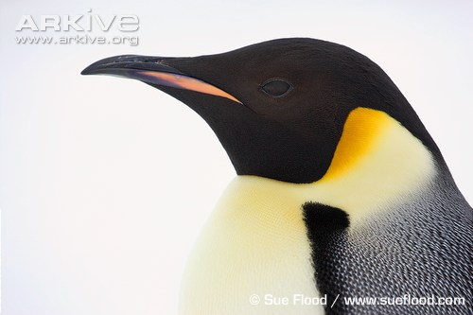
Emperor penguin

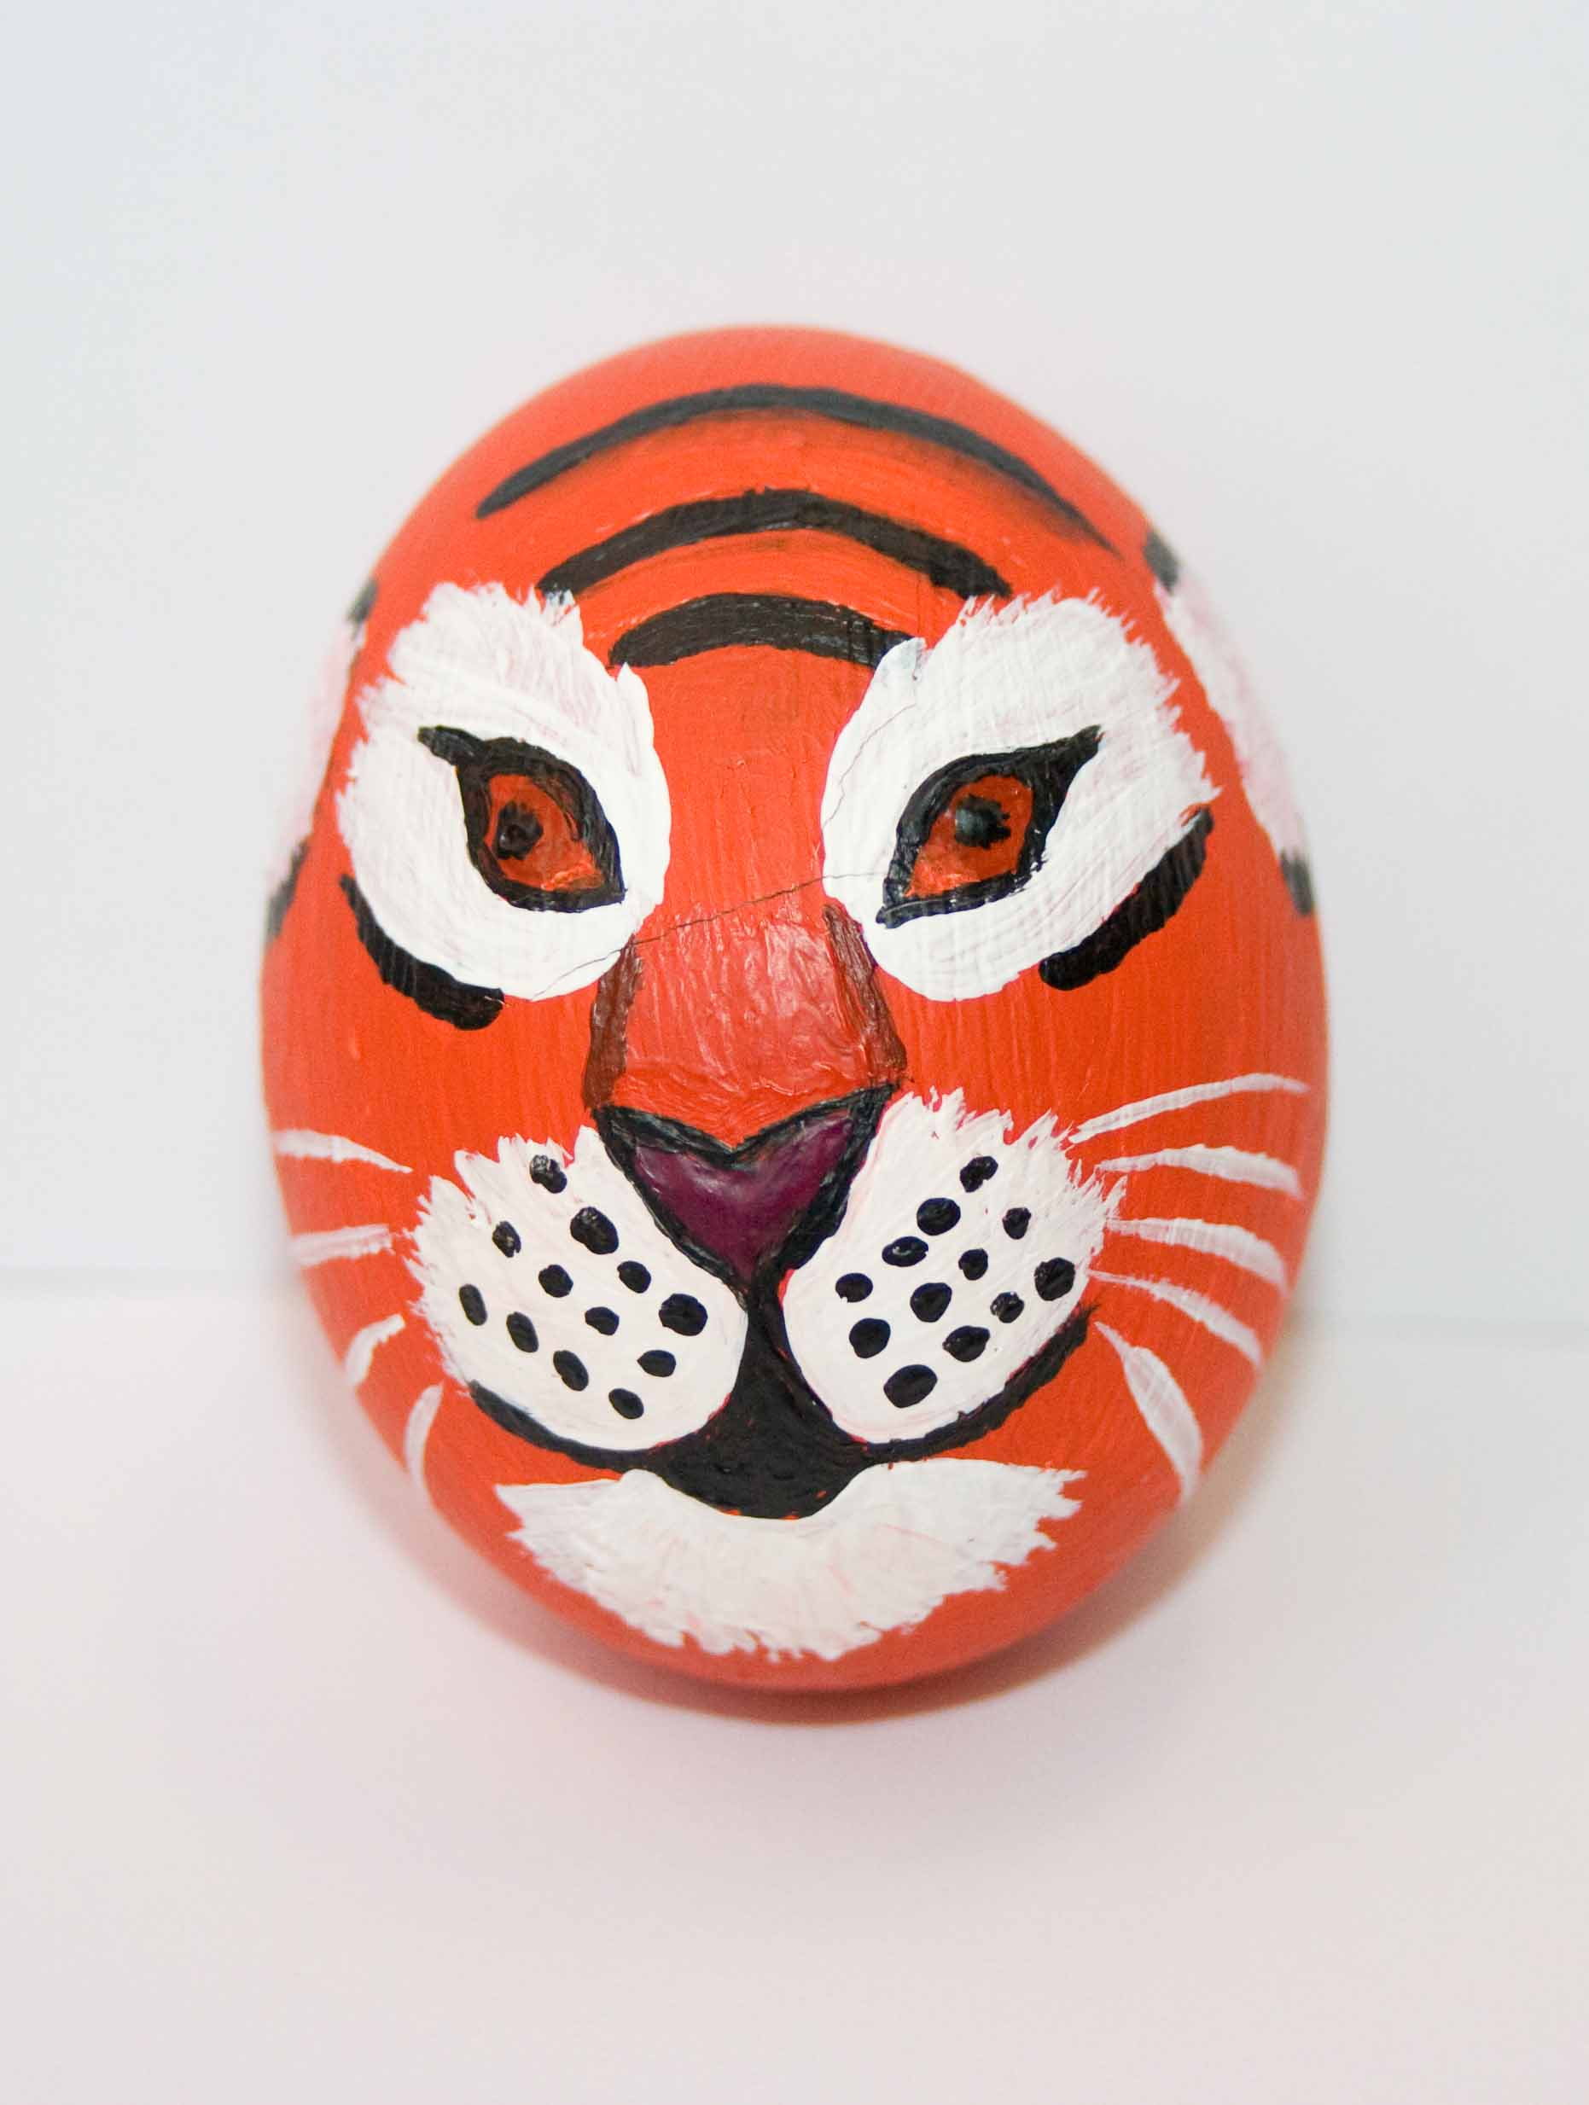
Tiger

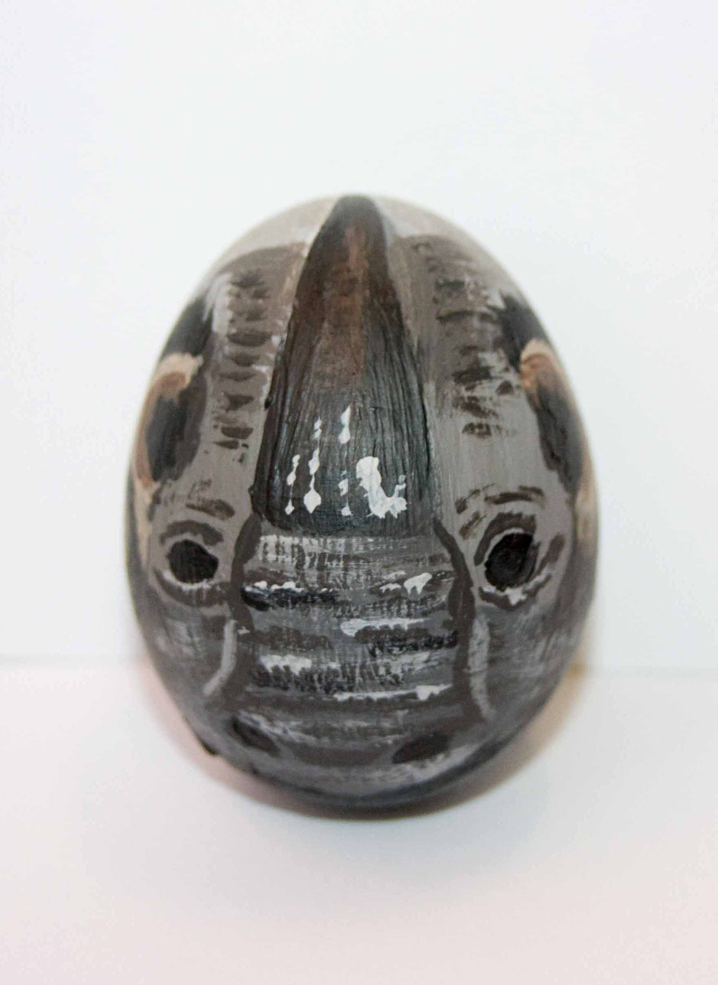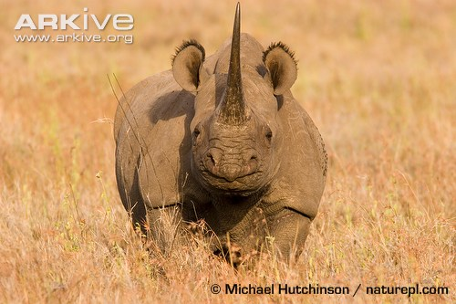
Black rhino
Join in the fun! Tweet photos of the decorated eggs to @ARKive or send them to arkive@wildscreen.org.uk so we can tweet them for you!

