**Sports Report Autumn 2015**

Pensilva secured their second Gold level award for the high profile of sport throughout the school and dedication to regular, active and fun PE lessons. It also recognises the variety of extra-curricular opportunities.

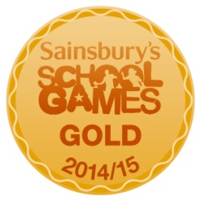

Yr 1/2 …

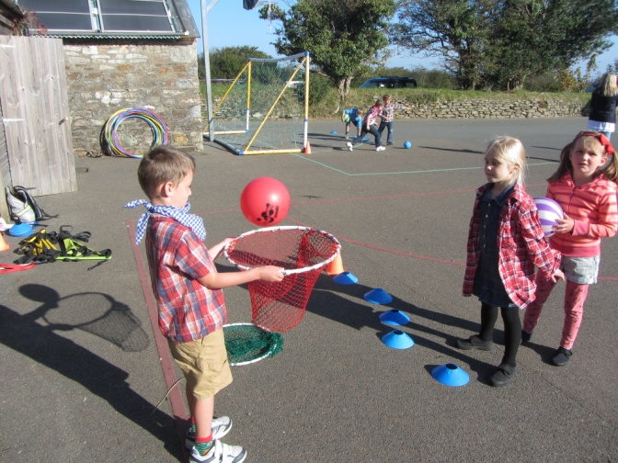 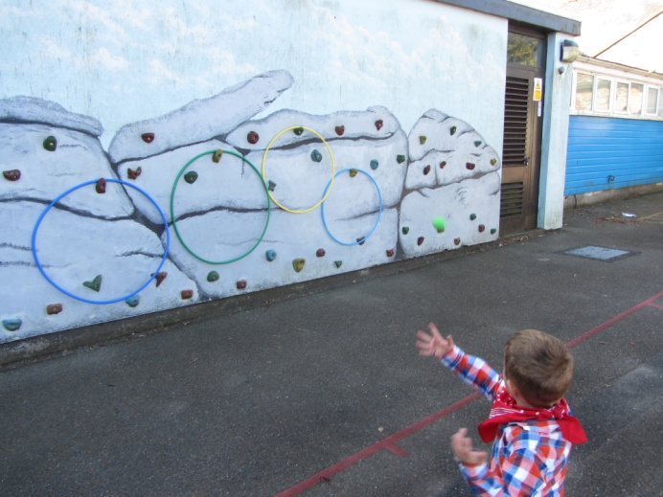

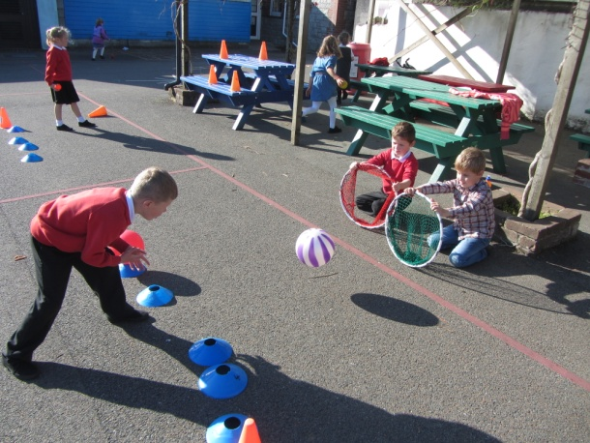 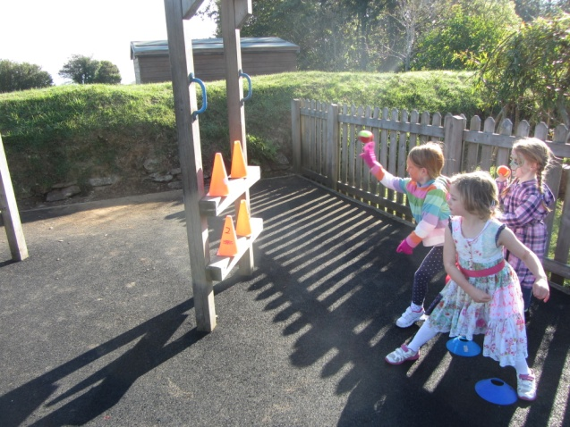

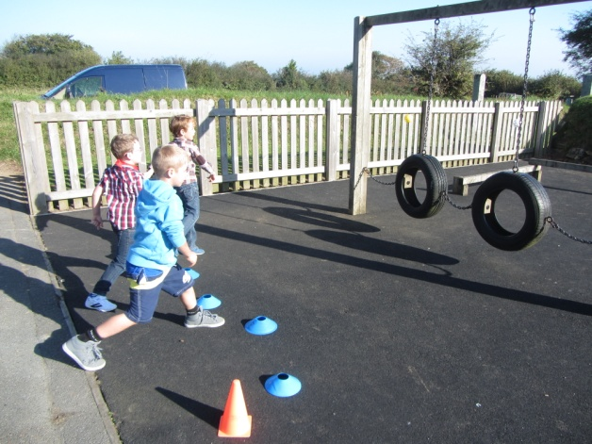 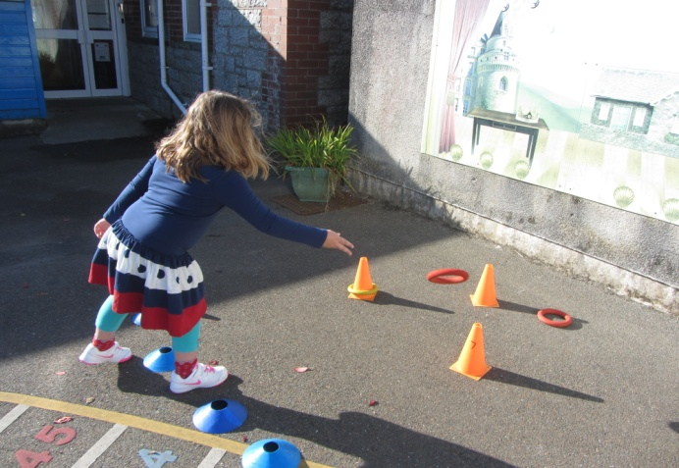

Yr 3/4…

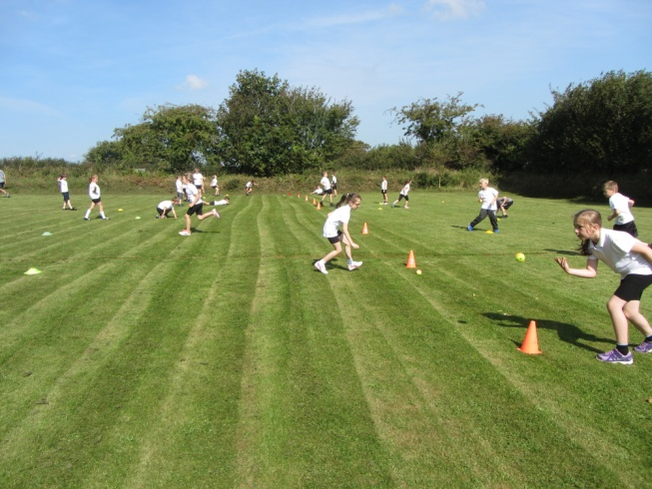 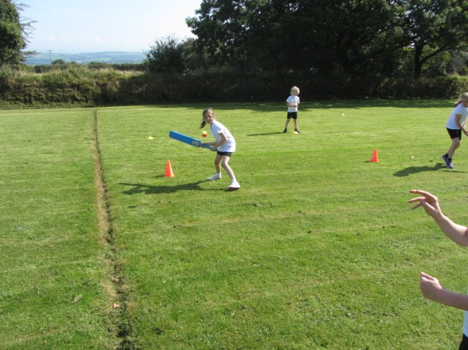

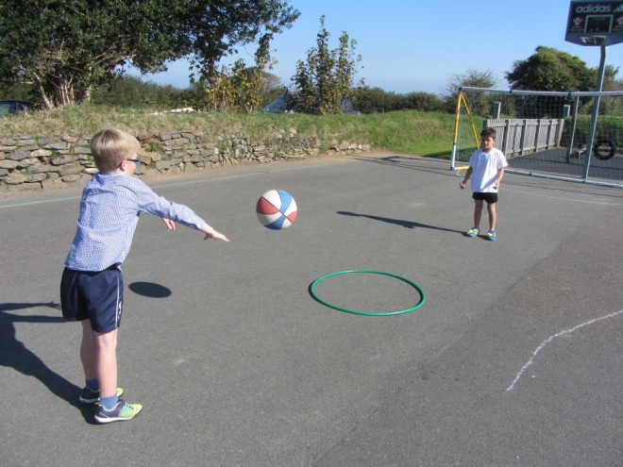 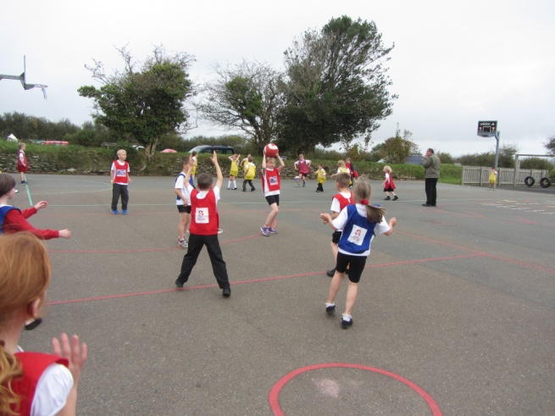

Yr 4/5…

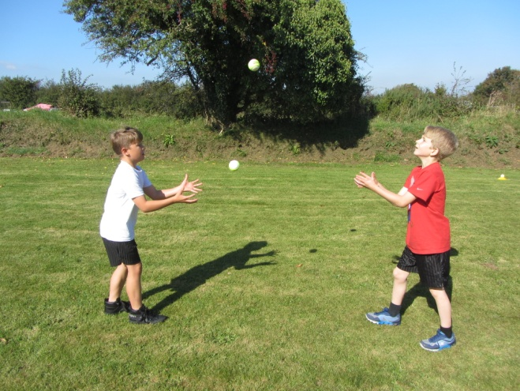 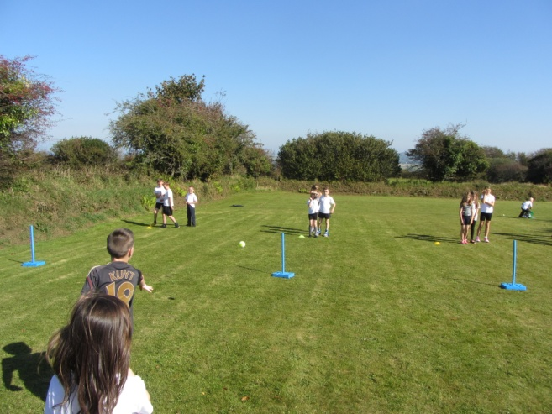

Yr 6…

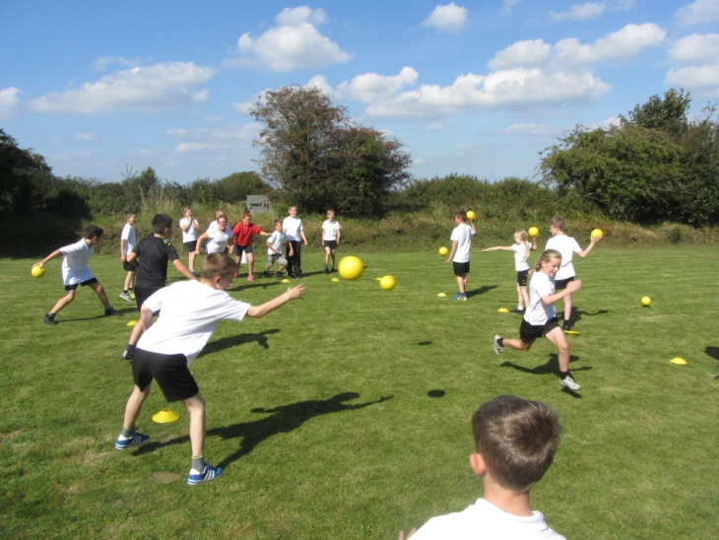 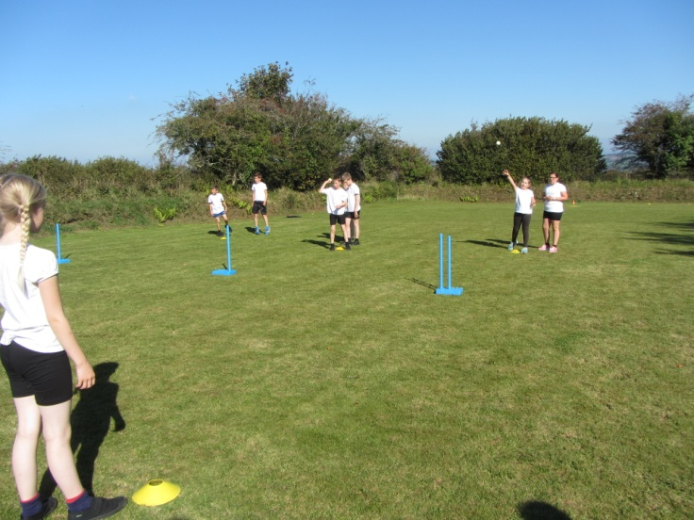

Year 6 have also been trained in Sports Leadership, planning and delivering active sessions to the new Reception class!! These groups will have a rota for lunchtime activities for the infants.

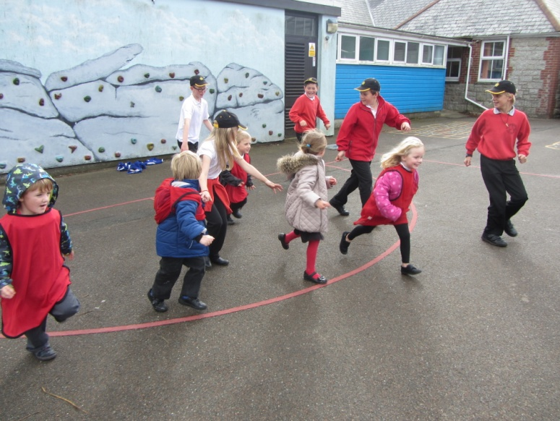 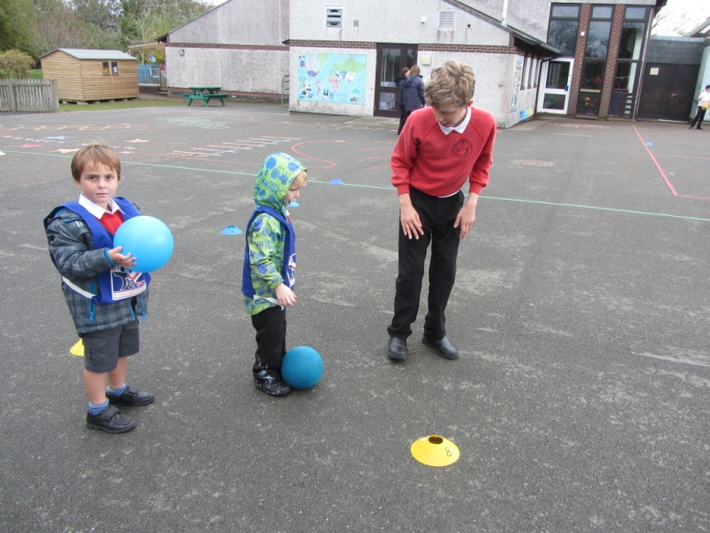

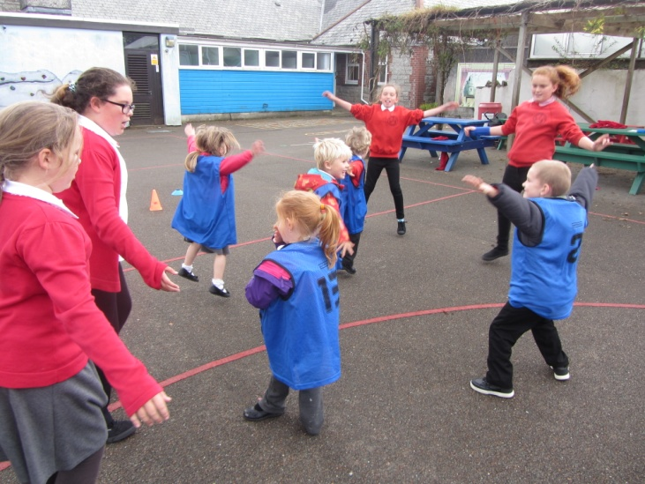 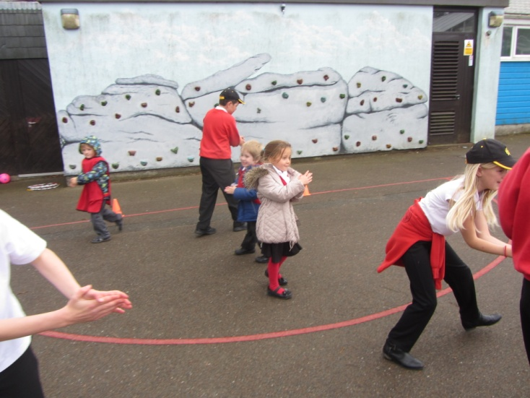

**Futsol!!**

Mr Jones arranged for football specialist to come and deliver some football skills and introduce the new game of small sided football called Futsol. He said afterwards that Pensilva was the best school for motivated pupils he had been in so far!!

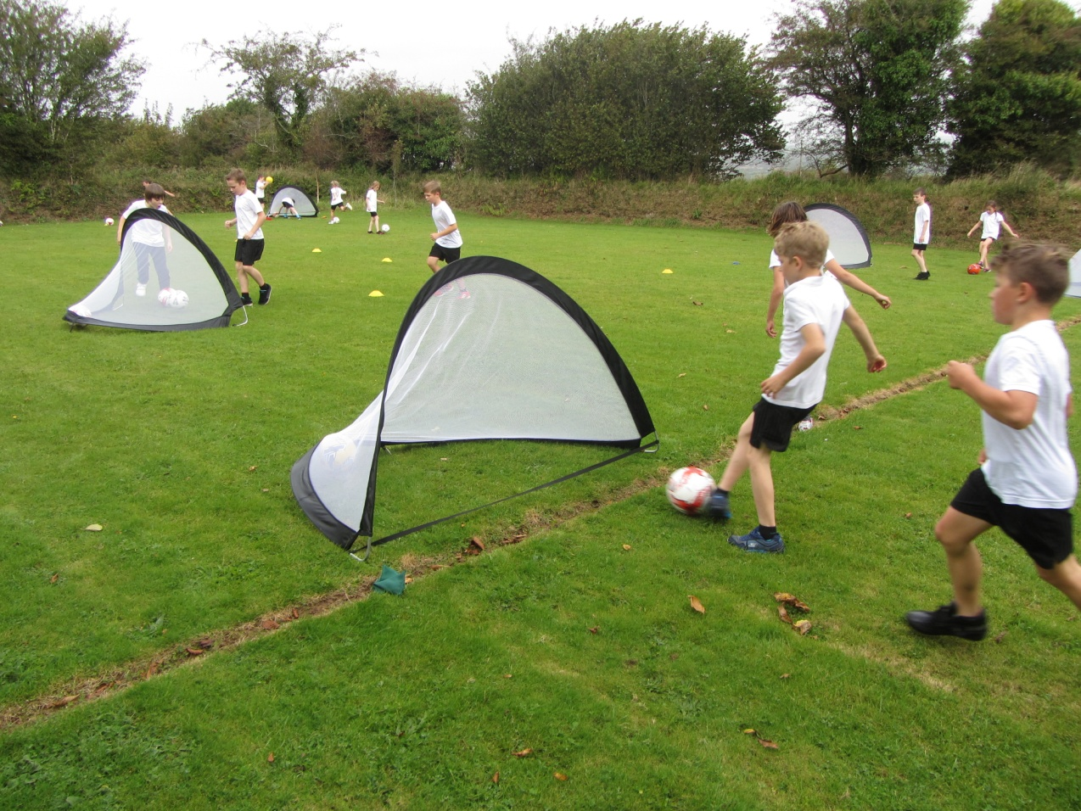

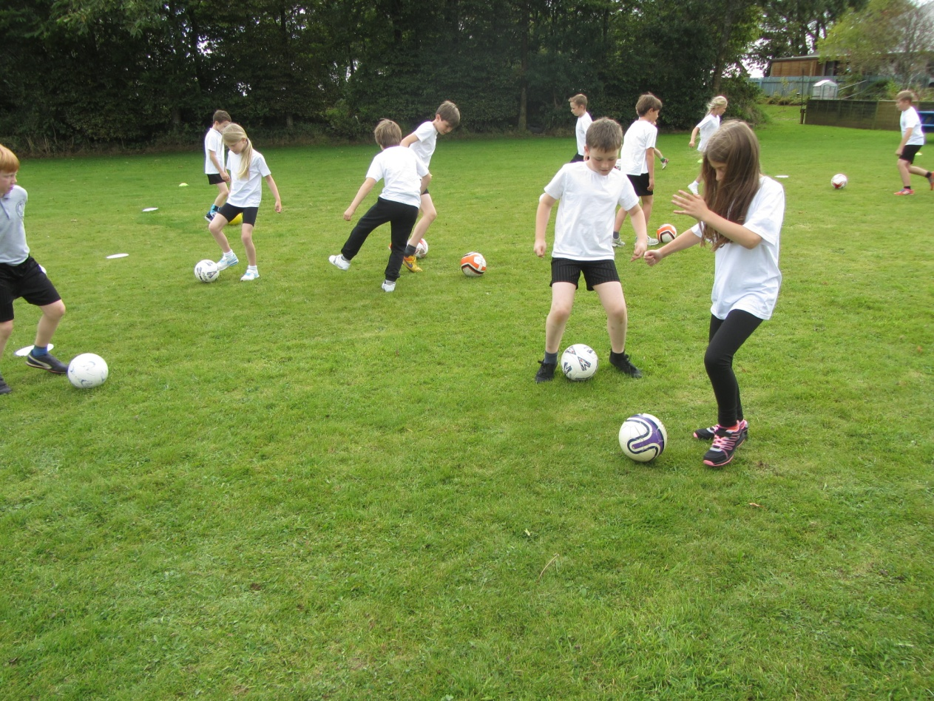

Grass Track Cycling!

Pensilva took part in the Grass Track Championships for the first time in Newquay and had a fantastic afternoon. Well done all!

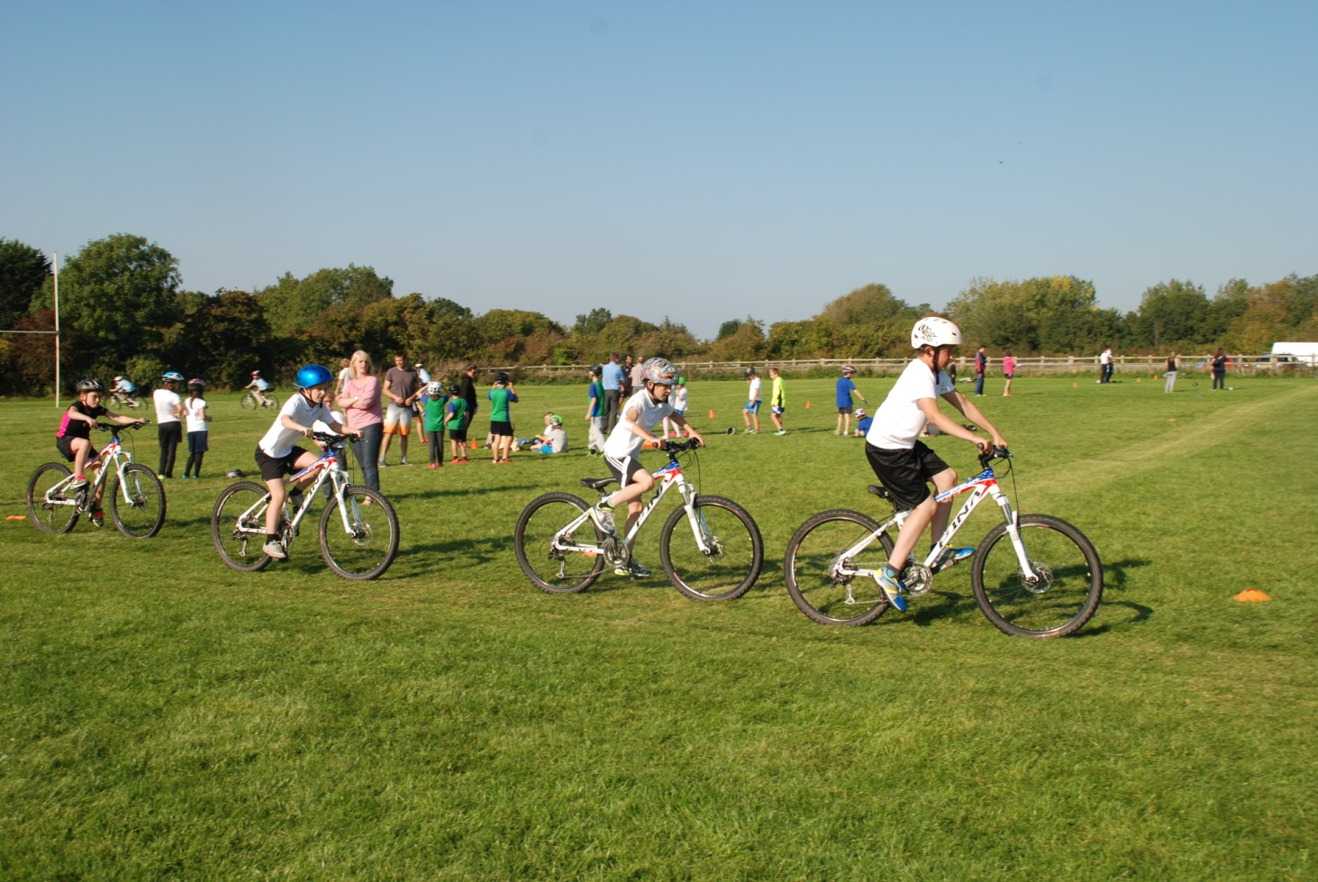

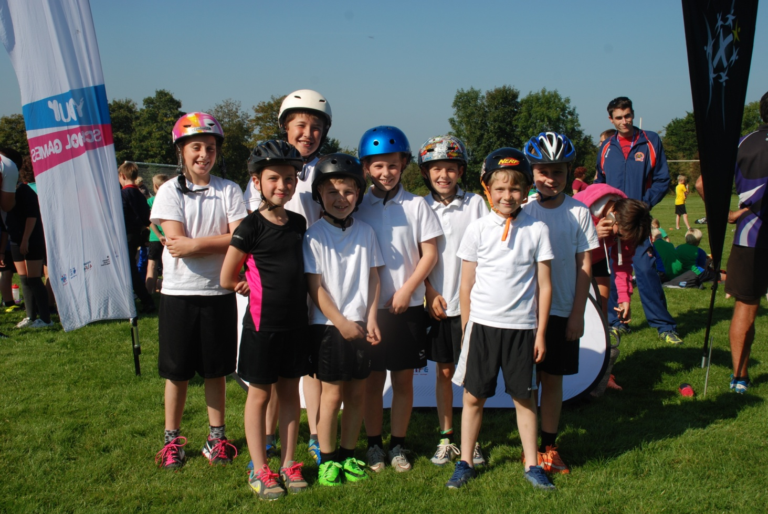

**Clubs**

Lots of sporty clubs are taking place for infants and Juniors such as cross country, hockey and netball.

