Virtual Museum
Now that you have planned what to write about your item for a museum 5000 years from now or an alien visiting Earth, you can write it out neatly, or type it, and think about how you will clearly lay out your information. When writing your information card, use some of the verbs below and you should find that some of your sentences start to sound like the museum labels you have been reading:
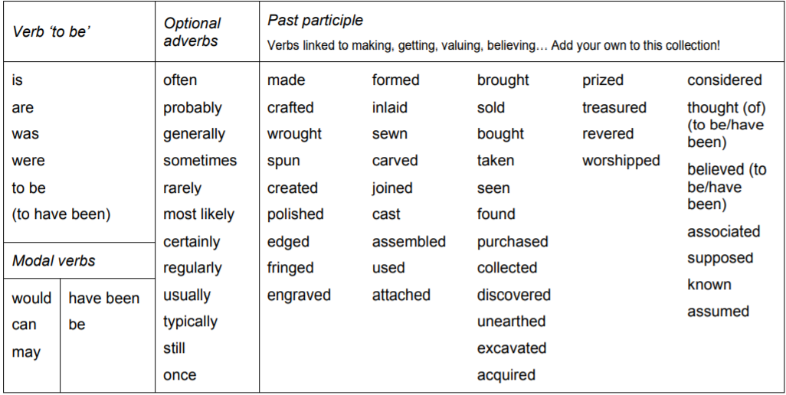
You could cut a piece of A4 paper in half for your information card and then mount the finished product on some card to make it look more authentic!
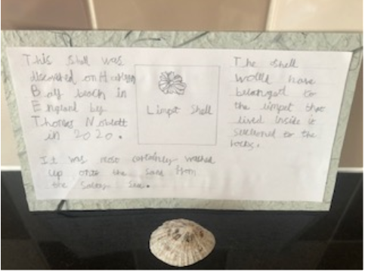
Here is an example of a finished information card about a shell:

