Summer Term PE report 2016
Badminton!!!- A sport which is shied upon in Primary schools due to the limitations of equipment and space has been actively taught by Mr Jones in all classes. Badminton England approached Mr Jones to pilot a new Scheme of work and has lent him equipment worth over £300 to use with children. The emphasis is on active fun and introducing the game. As a result of the initial success so far, Badminton England have agreed to pay the hire costs of the millennium Centre so that the school can have their first after school club in Badminton.
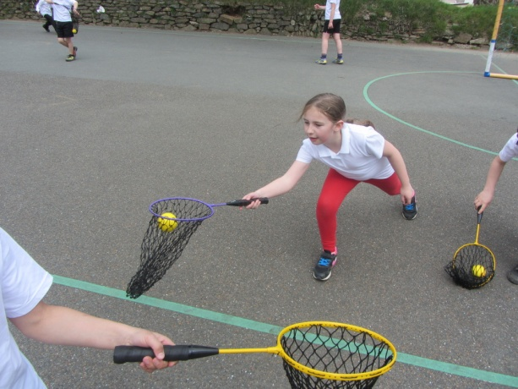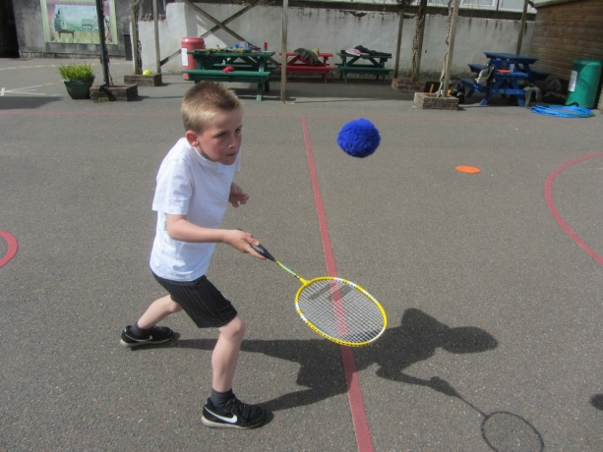
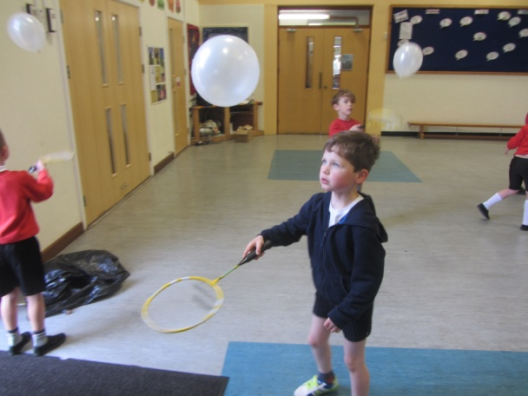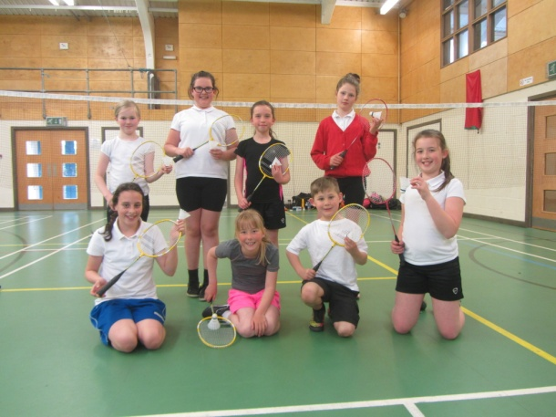
Swimming starts this term at Lux Park Leisure Centre.

