PE Update March 2018

The term has begun with Oli giving feedback during a staff meeting on the latest “Sugarsmart” initiative. This is based on the soft drinks companies being taxed more for the amount of sugar in drinks. This has led to the doubling of Sports premium. Staff looked at “Active timetables” where areas of inactivity throughout the day could be analysed and ideas to increase activity levels. Oli explained that the government were targeting whole school “Physical Activity” and that every child should be getting 30min of moderate activity a day in school and 30 min out of school.
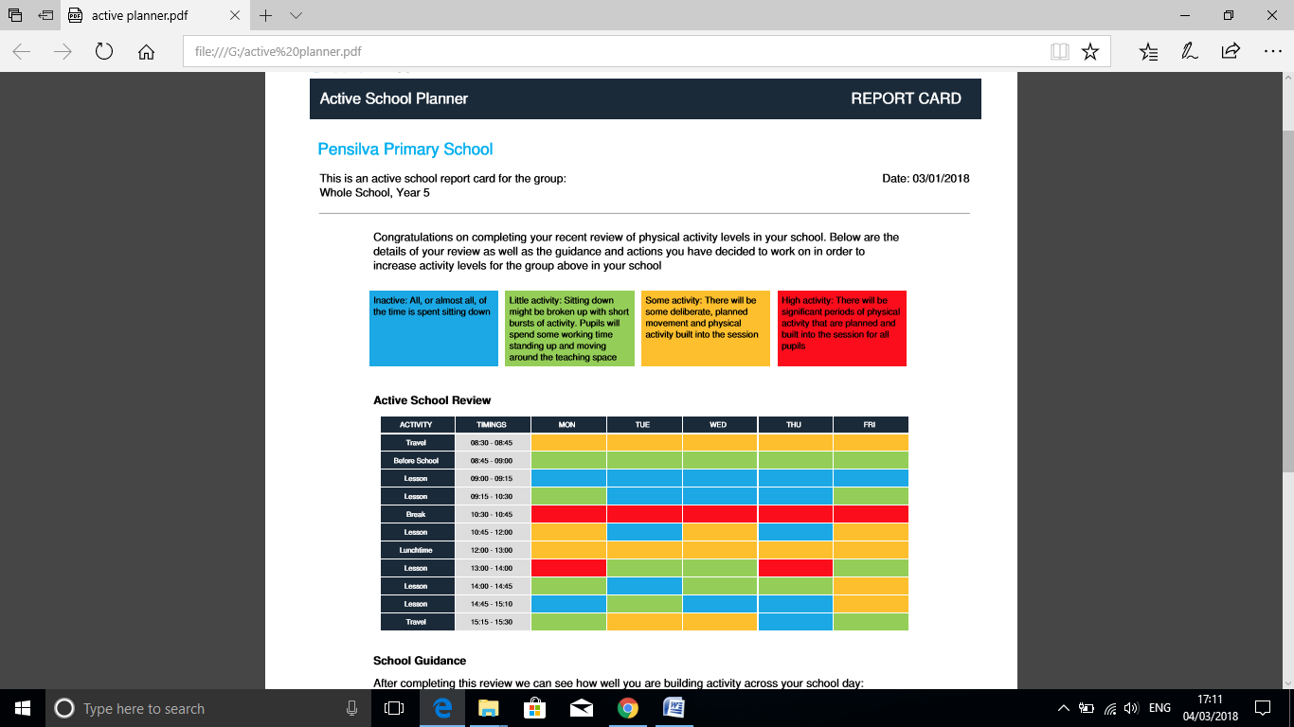

The activity could be in the form of standing more, moving around the school and active maths/literacy, active playtimes, travelling to school and PE.
Staff were keen to assess their classrooms and see where more activity could take place. Jen and I have reviewed playground Markings and have had a meeting with a Thermoplastic rep to get a quote of new courts and a fitness area which would enhance playground activity levels.

Festivals
We have been forging good links with Callington Community college who have invited us to various Sports Festivals. Warleggan attended a Multi skills festival in January which was highly thought of by the children and KS1 are attending one soon. We are also sending a squad of Hockey Players to play in our School Cluster.

Clubs
We had another successful “Playground to 5Km club with many parents and children participating. The club has even encouraged two mums to sign up for their first half marathons later in the year! Good luck!

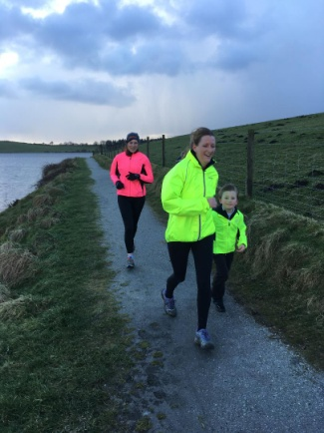

Gymnastics
Classes were able to use the brilliant facilities offered by the school. The quality of sequences and balances were very high compared to other schools.
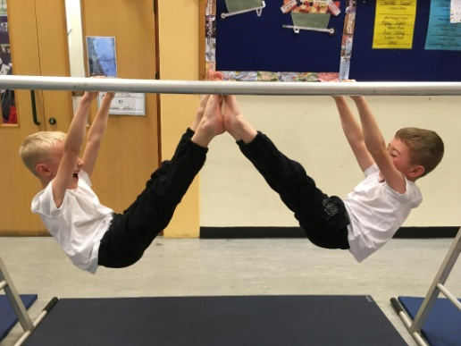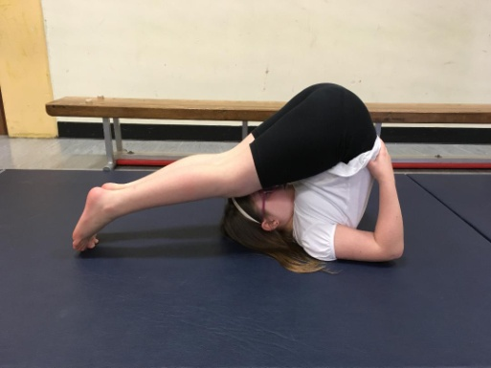

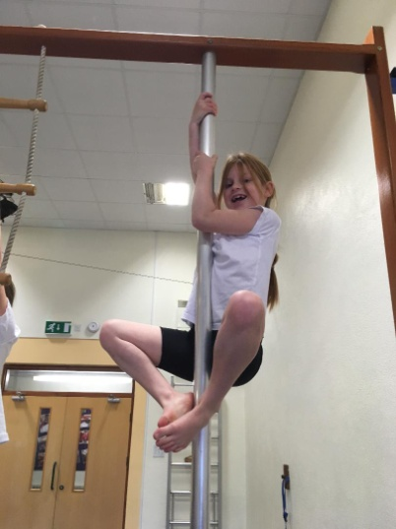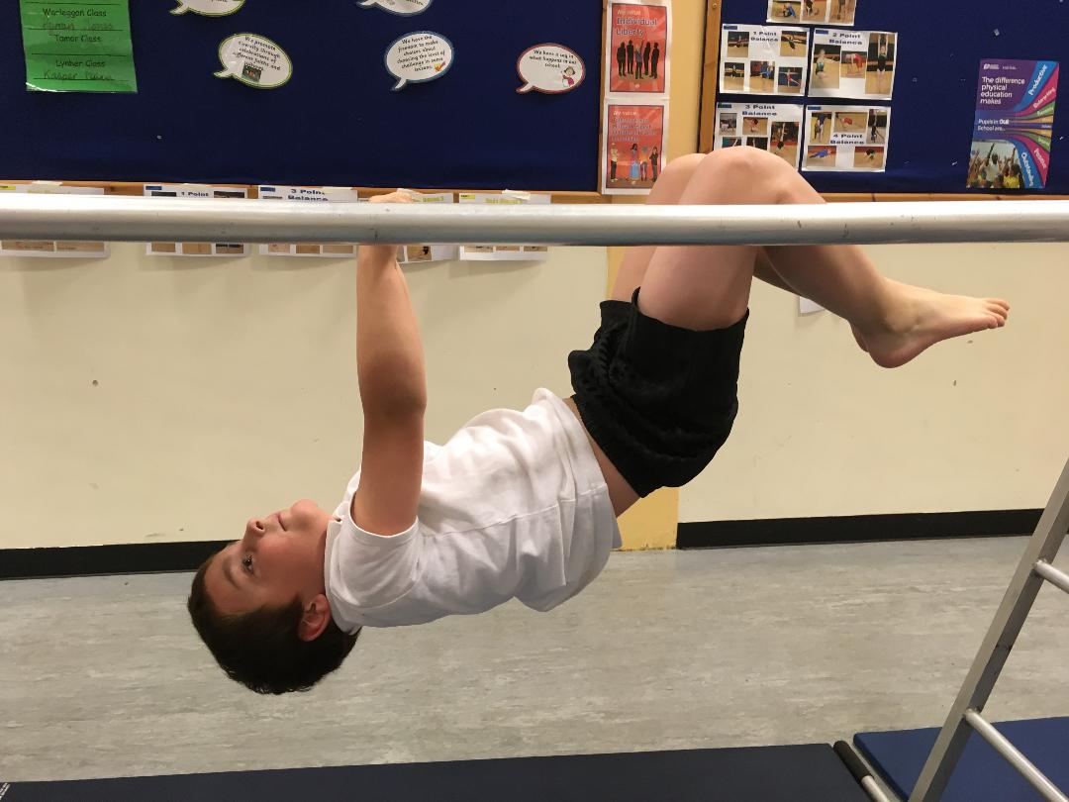

Arc of Attrition-100 challenge
Mr Jones completed the Arc of Attrition and set children homework of activities which involved 100 of something e.g. 100 skips etc. A number of children took part in this.

