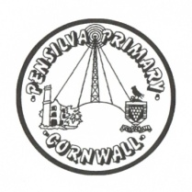
Puffin Class Home-School Communication Sheet
Week beginning Monday 14th May 2021.
School Dinner Week 3

This week’s diary |  | The G7 Summit in Cornwall!  The G7 Environment, Energy and Ocean Ministers will  discuss the theme, 'Working together on climate change, oceans and clean energy'.  On Tuesday 8th June, it was World Oceans Day and so we decided to research how important our oceans are to us.  We discovered oceans cover over 70% of the Earth’s surface. They provide us with over half of the oxygen that we breathe every day and absorb half of the world’s carbon dioxide. They are also home to about 80% of life on Earth. The oceans help to keep our planet at the correct temperature by absorbing heat from the sun.  We need to look after our oceans and so we designed posters to educate others on how important our oceans are and what we can do to look after them. We have displayed our posters in our window, please come and have a look!  In PE, we showed great teamwork and resilience! We used our tennis, skipping, throwing, catching and running skills.  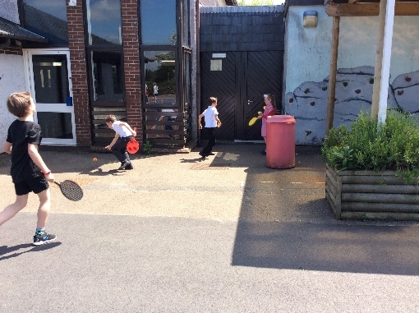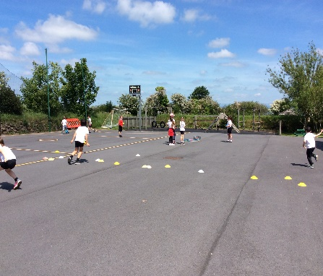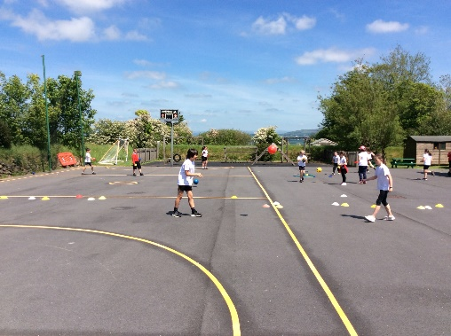  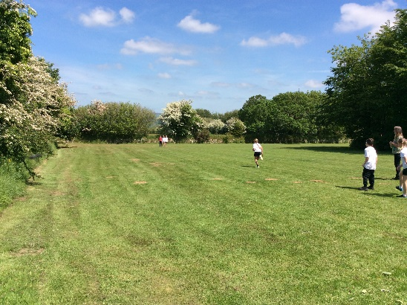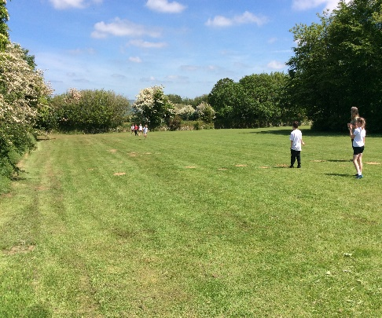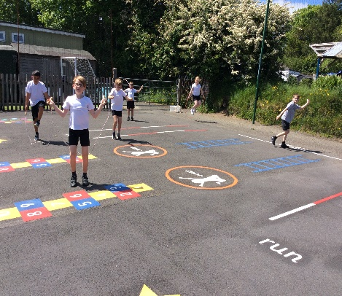  Please can you make sure children have a full, named PE kit in school. (Tuesday and Wednesday)  Year 3 and 4 need their swimming costumes and a towel (Tuesday 15th June to Friday 18th June)  Homework has been set on mathletics.com and spag.com and logins for these sites are in the children’s reading records. We have also sent home all of the logins on a piece of card. Please make sure you also challenge yourself on Times Table Rockstars.  Spellings will be sent home on Monday to learn for a spelling test on Friday.
Monday | Mrs Palfrey  Library books
Tuesday | Mrs Palfrey  PE
Wednesday | Mrs Palfrey  PE with Mr Jones.  PPA Cover (p.m.) Mrs McDowell
Thursday | Mrs Palfrey
Friday | Mrs Palfrey  Spelling Test | Upcoming dates  - Monday 14th June – Inset Day  - Tuesday 15th June to Friday 18th June – Year 3 and 4 swimming every afternoon.
Other information
Please feel free to send me an email if you have any questions or concerns. bpalfrey@pensilva.cornwall.sch.uk
Do not forget the school website for information on school events, policies and newsletters. http://pensilva.eschools.co.uk/website or our Facebook page

