Key Instant Recall Facts
Year 6 - Autumn term 1.
I know square numbers to 12 x 12
What is a square number
A squared number is simply a number that is multiplied by itself.
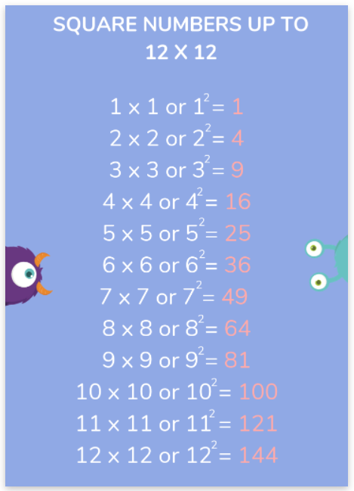
It is important to know our squared numbers because they can help us with lots of mathematical problems like finding the area of shapes or solving problems using our multiplication tables.
