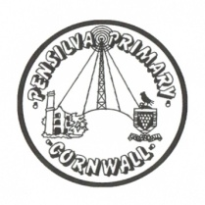
Wren’s Class Home-School Communication Sheet
Week beginning 17th May
School dinner week 3

This week’s diary |  | Hello Wrens.  We have had a very exciting week this week. We have been writing instructions for making a jam sandwich and all the year ones supported some reception children to follow their instructions and make their own sandwich. In computing the children have been learning how to log onto the laptops using their passwords and next week we are going to be talking about internet safety and doing some exploring of a safe and age appropriate website. We also painted the background of our moving picture books that we are making and had lots of time outside (between the rain showers)  Next week Mrs Thomas is out of class and the children will have Mrs McDowell on Monday and Miss King for the rest of the week.  On Friday the year 1s have their hearing screening test. This is a simple test that is not stressful for the children. You will receive a letter the same day informing you of any results.
Monday | Mrs McDowell
Tuesday | Miss King
Wednesday | Miss King  Mrs McDowell & PE with Mr Jones PM
Thursday | Miss King  PE with PAFC (PM)
Friday | Miss King | Upcoming dates:  Friday 21st May – Year 1 hearing screening.  Friday 28th May – Last day of term.
Other information
Please feel free to send us an email if you have any questions or concerns: Jthomas@pensilva.cornwall.sch.uk lking@pensilva.cornwall.sch.uk
Do not forget the school website; http://pensilva.eschools.co.uk/website for information on school events, policies and newsletters or our Facebook page; Pensilva Primary School for updates.

