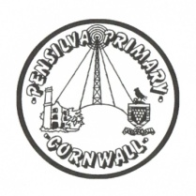
Puffin Class Home-School Communication Sheet
Week beginning Monday 15th November 2021.
School Dinner Week 3

This week’s diary |  | I am so proud of you Puffin Class.  In English this week we have been learning about writing instructions. We decided to make a poppy wreath for Remembrance Day and then wrote a set of instructions so other classes could hopefully follow them and make one for themselves. Puffin class have been able to list the features of a successful set of instructions, we know our instructions need a title, opening statement, subheadings (what you need and what you do) bullet points, numbered steps, imperative verbs, adverbs, time conjunctions, diagrams.  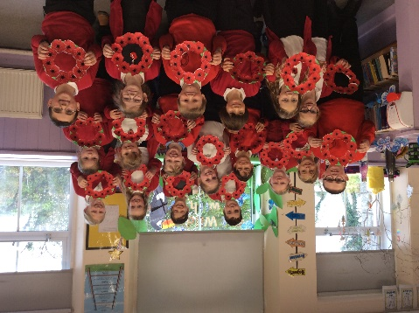  In maths we have focused on our KIRFS (Key Instant Recall Facts) Year 3 have been learning their 3 x tables and Year 4 have been learning their 7 x tables.  In science we have learning about the human digestive system. We then had a go at identifying and labelling parts of our digestive system.  Please can you make sure you listen to your child read and ask them questions about the story. Please remember to sign their reading record. Once you have finished reading a book, my comprehension group will complete a REN test to see if they have understood what they have read.  Please can you make sure children have a full, named PE kit in school. (Thursday and Friday)  Homework  Homework will be set on a Friday and handed in the following Friday.  Spellings and times tables will be given on a Friday to learn for a spelling and times tables test the following Friday.  Please encourage your child challenge themselves on Times Table Rockstars and Mathletics.  Library books can be chosen and taken home on a Monday.
Monday | Mrs Palfrey  Library books  Mrs Harris
Tuesday | Mrs Palfrey  Mrs Harris
Wednesday | Mrs Palfrey  Mrs Harris
Thursday | Mrs Palfrey  PE with Mr Jones.  PPA Cover (p.m.) Mrs McDowell  Mrs Harris
Friday | Mrs Palfrey  Mrs Harris  PE  Spelling/times table test | Upcoming dates  - Children in Need mufti (£1 voluntary donation)– Friday 19th November.  - Wren and Dove class trip to the theatre (Wednesday 8th December)  - Christmas jumper day, £1 donation non-school uniform (Friday 10th December)  - Christmas lunch (Wednesday 15th December)  - Mufti day £1 donation to raise money for the PSA. (Friday 17th December)
Other information
Please feel free to send me an email if you have any questions or concerns. bpalfrey@pensilva.cornwall.sch.uk
Do not forget the school website for information on school events, policies and newsletters. http://pensilva.eschools.co.uk/website or our Facebook page

