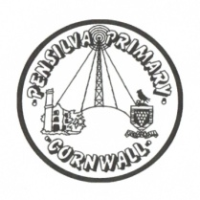
Wren’s Class Home-School Communication Sheet
Week beginning 26th April
School dinner week 3

This week’s diary |  | Hello Wrens! Welcome back. I hope you all had a lovely Easter Holiday with lots of fun and chocolate.  Our topic this term is challenge and we are starting with a mini topic on ‘The 3 little pigs and the big bad wolf’. The children have a farm and builders yard in their outside area and lots of drawing, maths and writing activities to complete over the next couple of weeks.  This week we have had such an exciting week. We planted beans to start our science project about plants and we also explored coding using coding critters and coding caterpillars.  For this term the children will have PE on Thursday and we are very lucky that Plymouth Argyle Football Club are coming in to do some PE sessions with them.
Monday | Miss Thomas
Tuesday | Miss Thomas
Wednesday | Miss King  Mrs McDowell & PE with Mr Jones PM
Thursday | Miss King  PE with PAFC (PM)
Friday | Miss King | Upcoming dates:  Monday 3rd May – Bank Holiday – School Closed  Friday 21st May – Year 1 hearing screening.  Friday 28th May – Last day of term.
Other information
Please feel free to send us an email if you have any questions or concerns: Jthomas@pensilva.cornwall.sch.uk lking@pensilva.cornwall.sch.uk
Do not forget the school website; http://pensilva.eschools.co.uk/website for information on school events, policies and newsletters or our Facebook page; Pensilva Primary School for updates.

