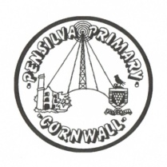
Wren’s Class Home-School Communication Sheet
Week commencing 28th February
Lunch menu week 3
This week’s diary |  | This week we will be celebrating St Piran’s day on Friday 4th March. The children will learn all about Cornish Saints and we will do some traditionally Cornish things like tasting scones.  Miss King might be teaching Monday and Tuesday as well as her regular days this week as Miss Thomas has appointments.  We will also be starting our new topics including learning all about ‘The Great Fire of London’ and what life in London was like in 1666.  I have been delighted to see all your ‘reading in unusual places’ pictures. Our reading area is looking much brighter and more colourful. Keep them coming in and we will add them to our reading area!  Finally balance ability will begin on Tuesday 1st for those children who are signed up. The children will go in small groups and each session will take 30 mins.
Monday | Miss King
Tuesday | Miss King
Wednesday | Miss King
Thursday | Miss King  Mrs McDowell & PE with Mr Jones PM
Friday | Miss King | Upcoming dates:  Pensilva Book Day – WEDESDAY 9TH MARCH!!
Other information
Please feel free to send us an email if you have any questions or concerns: Jthomas@pensilva.cornwall.sch.uk lking@pensilva.cornwall.sch.uk
Do not forget the school website; http://pensilva.eschools.co.uk/website for information on school events, policies and newsletters or our Facebook page; Pensilva Primary School for updates.

