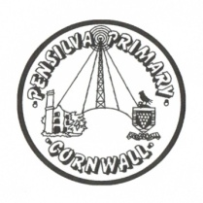
Wren’s Class Home-School Communication Sheet
Week beginning 20th September
School dinner: Week 1

This week’s diary |  | Wrens have had another amazing week and worked very hard. We started Read. Write, Inc this week.  Reception children: we looked at the letters m and a – you child will come home with these sound cards this week. Please practise saying the letter sounds and writing the letters. The children tried really hard to hold their pencils properly this week at school – please support them by continuing to encourage this at home as well.  Year 1 children were in all their different groups and may have been given a read, write, Inc book to read. If they didn’t get one this week they will get one next week.  We have also been reading the book ‘Monkey Puzzle’ by Julia Donaldson and thinking about what words best describe the different animals in the story. In maths we have been counting and recognising numbers.  .
Monday | Miss Thomas  (Mrs McDowell PM)
Tuesday | Miss Thomas
Wednesday | Miss King
Thursday | Miss King  Mrs McDowell & PE with Mr Jones PM
Friday | Miss King | Upcoming dates:
Other information
Please feel free to send us an email if you have any questions or concerns: Jthomas@pensilva.cornwall.sch.uk lking@pensilva.cornwall.sch.uk
Do not forget the school website; http://pensilva.eschools.co.uk/website for information on school events, policies and newsletters or our Facebook page; Pensilva Primary School for updates.

