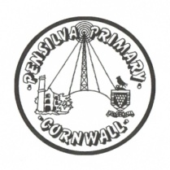
Puffin Class Home-School Communication Sheet
Week beginning Monday 8th November 2021.
School Dinner Week 2

This week’s diary |  | A great week Puffin Class.  In English we have been learning about James I of England and The Gunpowder Plot. We have sequenced these events and have written a newspaper article describing the plot against the king. We have also created our own persuasive poster to teach people about the firework safety code.  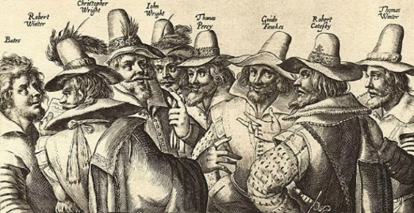  In maths we have focused on multiplication, Year 4 have been multiplying by 10 and 100 and year 3 have been investigating the link between multiplication and repeated addition, we have also been drawing an array.  In History, our new topic is ‘Riotous Royals’. Our first lesson was learning about William the Conqueror and The Battle of Hastings.  Please can you make sure you listen to your child read and ask them questions about the story. Please remember to sign their reading record. Once you have finished reading a book, my comprehension group will complete a REN test to see if they have understood what they have read.  Please can you make sure children have a full, named PE kit in school. (Thursday and Friday)  Homework  Homework will be set on a Friday and handed in the following Friday.  Spellings and times tables will be given on a Friday to learn for a spelling and times tables test the following Friday.  Please encourage your child challenge themselves on Times Table Rockstars and Mathletics.  Library books can be chosen and taken home on a Monday.
Monday | Mrs Palfrey  Library books  Mrs Harris
Tuesday | Mrs Palfrey  Mrs Harris
Wednesday | Mrs Palfrey  Mrs Harris
Thursday | Mrs Palfrey  PE with Mr Jones.  PPA Cover (p.m.) Mrs McDowell  Mrs Harris
Friday | Mrs Palfrey  Mrs Harris  PE  Spelling/times table test | Upcoming dates  - Children in Need mufti (£1 voluntary donation)– Friday 19th November
Other information
Please feel free to send me an email if you have any questions or concerns. bpalfrey@pensilva.cornwall.sch.uk
Do not forget the school website for information on school events, policies and newsletters. http://pensilva.eschools.co.uk/website or our Facebook page

