Wren’s PE Thursday 7th January

Feel free to select any of these ideas or do your own form of physical activity. I would love to see photos or any other ideas (email to Miss King)

Getting Outside Ideas:
Wrap up warm and go for a cold walk. Are there any puddles to jump in? Are they frozen, what colour are the leaves? What animals can you see? Did you see any seeds or berries in the bushes?
Stop for a few seconds and listen to the sounds all around you. Can you hear any birds, cars, people? What else can you hear?

Go for a bike or scooter ride (remember your helmet) – if you have any chalk you could draw yourself a course or use stones to mark out a course to try and bike or scoot along.

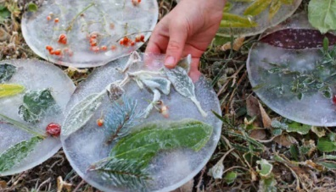
You could also make a frozen sun catcher – on your walk or bike ride collect some lovely leaves, berries, sticks etc (remember to wash your hands afterwards and never put any berries or leaves into your mouths). Once you have collected enough take them home and lay them all out in a plastic lid or shallow round tub. Fill with water and freeze overnight before carefully tipping them out. – if you leave a hoop of string in the water you should be able to hang them up in the garden until they melt.

Staying Inside Ideas:
Here are a few links to some online dance and exercise videos that you can try.
https://www.youtube.com/watch?v=kRw6sGwN4U4 Cosmic kids yoga – Skip to about 4.20 in to get straight to the yoga.

https://www.youtube.com/watch?v=emKoR6Mlr4I – I like to move it (kids Zumba)

Active 8 Minute Workout Featuring Alfie | The Body Coach TV - YouTube – Joe Wicks workout.

Our PE expert Oli Jones has also been doing a star jump challenge – to join in with this you can watch the video here: https://youtu.be/35iGUx5GAgo

