Key Instant Recall Facts
Year 1 - Autumn term 1.
I can count to 50 (and beyond)

By the end of this half term children should be able to count to 50 confidently.
Ways to help at home.
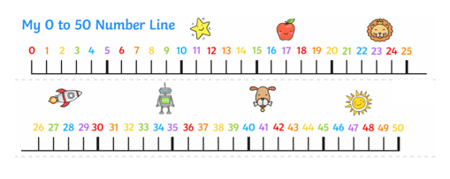
Remember: little and often is best!
Start by counting using the number line. Then you can see if your child can be more independent once they are confident.

You could: Count how long it takes you to walk up your stairs, collect leaves in the garden and count them, count how many grapes you have in your bowl. Any counting you can do is AMAZING!
You can also practise counting using these interactive counting squares online: https://www.topmarks.co.uk/learning-to-count/paint-the-squares

