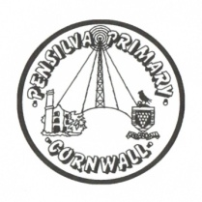
Wren Class Home-School Communication Sheet
Week beginning 23rd November 2020

This week’s diary |  | We have had a lovely week celebrating Diwali, we have enjoyed lots of craft activities and learnt the story of Rama and Sita.  Thank you for those of you that have helped your child do their homework! We are so impressed with the children’s efforts and the impact it has already made.  Reception children – Please trace over the letters we have written in the blue book and then try to write it 3 times next to it.  Year 1s please complete your spellings practice so you are prepared for the test on Fridays.  Please ensure your child’s blue homework book is kept in their bookbags, especially on Fridays so we can set new letters or spellings. We will ensure they are returned in their bookbags everyday too.
Monday | Mrs Palfrey
Tuesday | Mrs Palfrey
Wednesday | Mrs Palfrey  PE with Mr Jones.
Thursday | Miss Thomas
Friday | Miss Thomas | Upcoming dates:  Friday 11th December - Christmas Jumper day. £1 voluntary donation to Save the Children  Wednesday 16th December - Christmas lunch  Thursday 17th December - last day of term  Friday 18th December - INSET day. School closed  Monday 4th January - Spring term begins
Other information
Mrs Palfrey’s email address is bplfrey@pensilva.cornwall.sh.uk and Miss Thomas’s is jthomas@pensilva.cornwall.sch.uk
Do not forget the school website for information on school events, policies, newsletters and clubs. http://pensilva.eschools.co.uk/website or our Facebook page

