Daymer and Polzeath Children Home Learning w/c 29/6/2020
Hello everyone
We hope you have had a lovely week and enjoyed the lovely and not so lovely weather!
Please remember that is you wish to contact us about anything our contact details are:
jthomas@pensilva.cornwall.sch.uk or vholt@pensilva.cornwall.sch.uk

This week’s planning covers objectives for EYFS/Y1 and Year 2 – we have kept it fairly simple and then all children can access it at their own levels.
We are moving away from the seaside/water and our new topic will be MINIBEASTS as lots of the children in school have been having a lovely time going on minibeast hunts. They have found snails, worms, beetles, ants and even a toad! We thought those of you at home may enjoy one too!

Phonics
Thank you so much for those of you that completed the phonics and key words check list from last week. If you have not completed this yet please go to last weeks tab on the left and do so as it will help me organise groupings for September.
For those of you that did complete the lists please work through the sounds your child is not confident with, thank you.

Literacy/ Science
Monday
Go on a minibeast hunt in your garden or the park or maybe even in Pentiddy woods. Write down all the creatures that you find
- You could just write a list
- You could add in details about where you found each creature.
- If you were feeling really ambitions you could write a description of some of the creatures that you find.
Tuesday
All about insects!
Not all of the creatures that you find on your minibeast hunt will be insects so how do you know what is and isn’t and insect? Research this online and then in your home learning books write down the key characteristics of an insect.
Wednesday
Draw a line down the middle of one page in your home learning book. Label one side INSECT and the other side NOT INSECT.
Have a look at the list of minibeasts that you found on Monday- use the internet to find out about their characteristics and then decide which are and are not insects.
Thursday/ Friday
Choose one or more of your favourite Minibeasts and in your home learning books write a fact file for each one.
Include;
A title
A diagram with all the parts of the body labelled
What your minibeast eats
Where your minibeast lives

Maths
We would like all of the children to revisit counting in 10s, 5s and 2s.
Year 1 and 2 children please continue to complete the files attached below this document on the website.
Reception children, I have attached some generic maths activities and worksheets. Over the weeks we have covered lots of the areas that need to be and at this point in school we would be focussing on applying their learning to play and beginning to complete some more formal maths in preparation for Year 1. Once the activities have been completed please stick in their home learning books.
If you do not have access to a printer please contact myself or Miss Holt and we will leave the printed sheets in the school foyer, you will need to arrange a time to collect as access to the school is restricted without prior arrangement.

Art/DT
This week is children’s art week! We have attached lots of different art activities you could do with your children over the week, or create something of your own choice! Please send a picture of anything you do so we can display them!! Below is the art activity we would like you to do which links to this week’s topic. You can do either or all of them, whatever excites you and your child.
Can you make your own nature bugs like the ones below- go outside collect leaves, twigs stones etc – Let your imagination go wild! If you decide to make and insect then make sure it has all the key features of an insect! You could then label all the parts of your insect if you were feeling really clever.
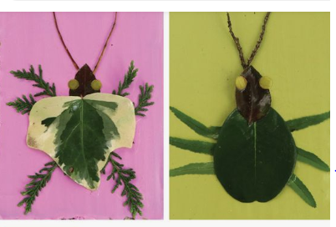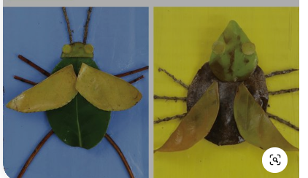
We would LOVE to see photos of your nature bugs so PLEASE send them in!

Science
Make your own wormery!
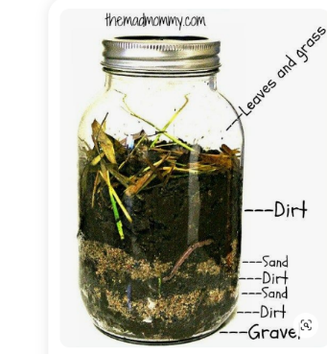
A Wormery is an easy, efficient system of converting ordinary kitchen food waste into liquid feed and rich organic compost through the natural action of worms. They are wonderful to have in your backyard to help with your garden.

TO MAKE YOUR OWN WORMERY, YOU WILL NEED:
- An empty jar (like a glass mason jar)
- 1/4 cup of gravel per jar
- dirt
- sand
- leaves and grass clippings
- 1 TBS of water
- and of course, WORMS! Earth and Gummy!

- Place the gravel in the bottom of the jar and then, alternate with layers of dirt and sand. (about an inch per layer) The last layer of dirt should be 2 – 3 inches to give the worms room to start.
- After you have made your layers, drizzle the water all over the top layer of dirt.
- Now, add 3 or 4 worms.
- Once your worms are in, gently place the leaves and grass on top and then, put on your lid. Please make sure that there are air holes in your lid!
- Place your wormery in a cool, dark place. You can check on it and make observations every few days.
- You can also add small, compost-able items to your wormery. Things like an apple peel, orange peel, a bit of lettuce stem and watch the worms work!

