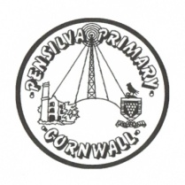
Dove’s Class Home-School Communication Sheet
Week beginning 29th November 2021
School dinner week 2
This week’s diary |  | Hello parent and carers  A reminder that children are bringing home a Read, write, inc reading book so please make sure you read these with your child on a daily basis as this will reinforce what they are doing in school and help them progress well.  PE days are Monday and Thursday so please ensure you have a PE kit in school on those days, labelled with your child(ren)’s names. Please only provide laces if your child can do them up themselves.  Homework  Weekly spellings have been sent home to learn for a test on Friday.  Reading – read your Read, Write, Inc book at least three times a week.  Maths – There has been a shape task set for each year group on Mathletics.  There will be no other homework this week due to being unable to print today but some children have lines to learn for the Christmas Production ‘Whoops-a-Daisy Angel’.
Monday | Mrs Noblett  PE
Tuesday | Mrs Noblett  (Mrs McDowell PM)
Wednesday | Mrs Noblett
Thursday | Mrs Noblett  PE with Mr Jones  Library
Friday | Mrs Noblett  Spelling test | Upcoming dates:  - Theatre Royal trip – Wednesday 8th December  - Last day of term – Friday 17th December
Other information
Please feel free to send us an email if you have any questions or concerns: nnoblett@pensilva.cornwall.sch.uk
Do not forget the school website; http://pensilva.eschools.co.uk/website for information on school events, policies and newsletters or our Facebook page; Pensilva Primary School for updates.

