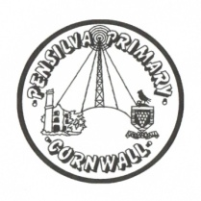
Puffin Class Home-School Communication Sheet
Week beginning Monday 12th July 2021.
School Dinner Week 1

This week’s diary |  | Puffin Class have been designing and creating their own persuasive advert for a toy. They used a word document to explore a variety of fonts and images. They then successfully saved their work in a folder on our network.  In maths, we have been measuring mass and capacity. The practical activities were lots of fun.  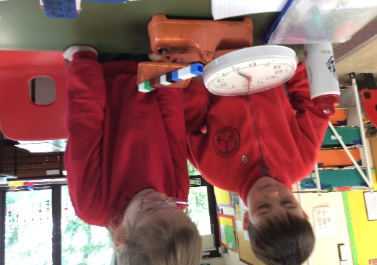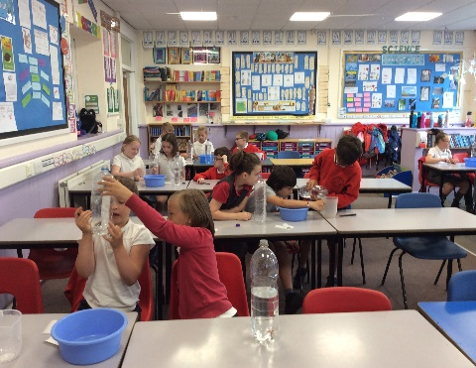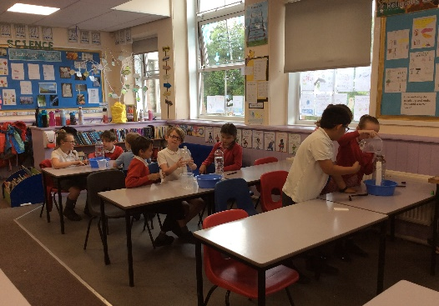  Please can you make sure children have a full, named PE kit in school. (Tuesday and Wednesday)  Homework has been set on mathletics.com and spag.com and logins for these sites are in the children’s reading records. We have also sent home all of the logins on a piece of card. Please make sure you also challenge yourself on Times Table Rockstars.  Spellings will be sent home on Monday to learn for a spelling test on Friday.
Monday | Mrs Palfrey  Library books
Tuesday | Mrs Palfrey  PE
Wednesday | Mrs Palfrey  PE with Mr Jones.  PPA Cover (p.m.) Mrs McDowell
Thursday | Mrs Palfrey
Friday | Mrs Palfrey  Spelling Test | Upcoming dates  - Thursday 22nd July – last day of term.
Other information
Please feel free to send me an email if you have any questions or concerns. bpalfrey@pensilva.cornwall.sch.uk
Do not forget the school website for information on school events, policies and newsletters. http://pensilva.eschools.co.uk/website or our Facebook page

