Key Instant Recall Facts
Reception - Autumn term 2.
I can name write the numbers to 5
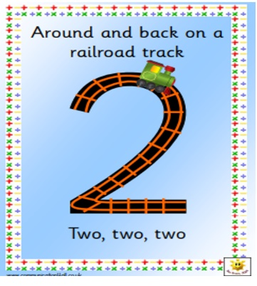
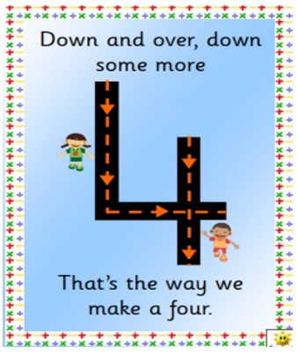
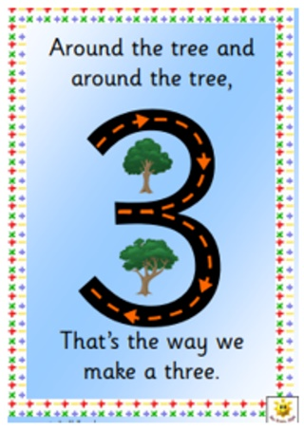
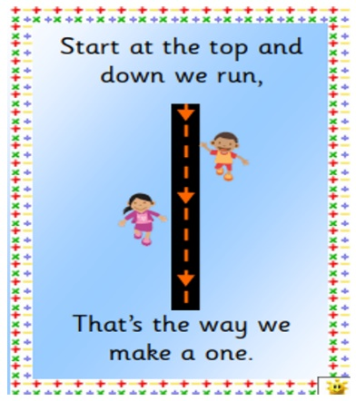
By the end of this term your child should be able to write the numbers to 5. You can use these pictures to support number formation.
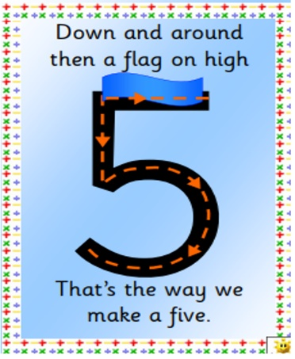

Ways to help at home – practise writing these numbers whenever you can! Even writing one number a night at home will mean they have practised all 5 by the end of the week.
If you are writing a shopping list you could ask your child to help you write how many of each object you need.
You could also paint the numbers, write them in sand, make them out of pasta or beads (or any other creative way that you can think of to support your child in this).

