**Similarities and Differences**

**Looe  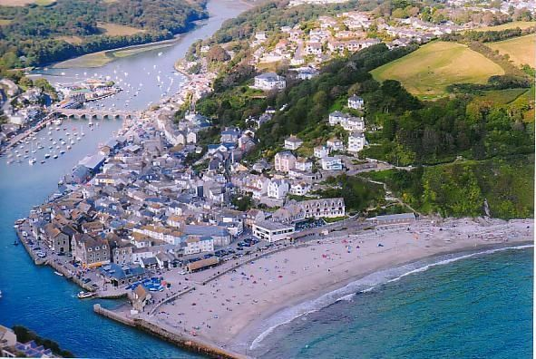  Pensilva** 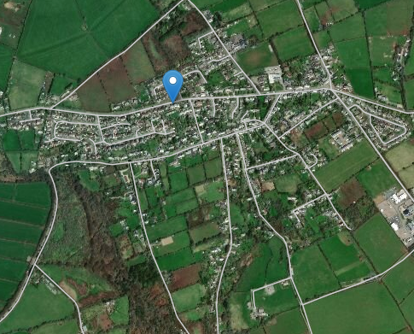

|  |  |
| --- | --- |
| Similarities | Differences |
|  |  |