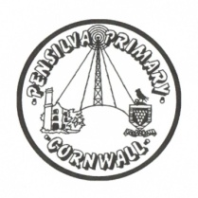
Wren’s Class Home-School Communication Sheet
Week beginning 27th September
School dinner: Week 2

This week’s diary |  | Well done Wrens on a very busy 3rd week.  We have continued our work on ‘Monkey Puzzle’ and the children all made masks and had fun acting out the story. We also did some shared writing and the year 1 children all wrote some super sentences in their books.  Reception children used their chat books to write or draw about their weekends.  The children are doing very well learning their sounds and forming their letters. Please continue to practise these at home as this really supports the work they are doing in school.  In maths we continued our work on number and used number lines to find one more and one less. The year 1 children have been practising their problem solving skills too!  In art we used our new sketch books and the children all used a range of pens, pastels and coloured paper to turn circles into amazing creations.  .
Monday | Miss Thomas  (Mrs McDowell PM)
Tuesday | Miss Thomas
Wednesday | Miss King
Thursday | Miss King  Mrs McDowell & PE with Mr Jones PM
Friday | Miss King | Upcoming dates:  Friday 8th Nov – non school uniform day.
Other information
Please feel free to send us an email if you have any questions or concerns: Jthomas@pensilva.cornwall.sch.uk lking@pensilva.cornwall.sch.uk
Do not forget the school website; http://pensilva.eschools.co.uk/website for information on school events, policies and newsletters or our Facebook page; Pensilva Primary School for updates.

