Pensilva Sport Report
October 2021
We had new playground markings including a fitness trail which has been so welcomed.
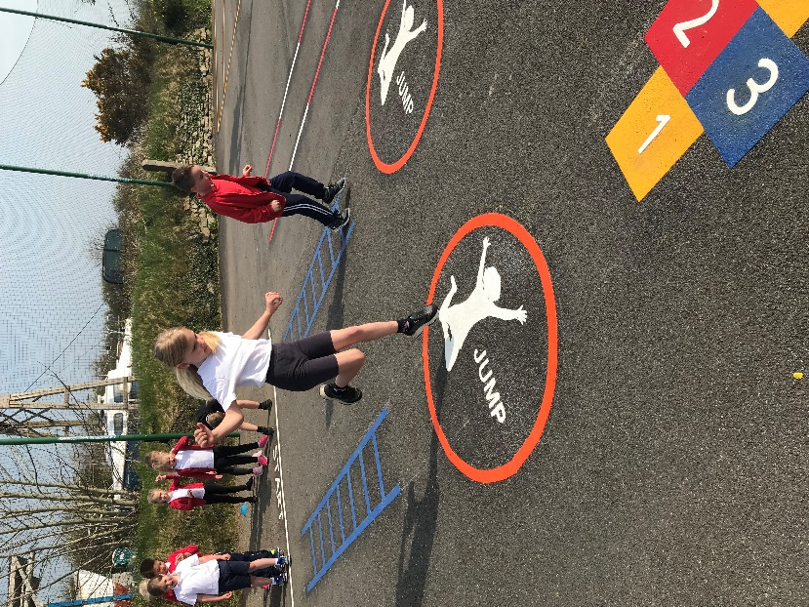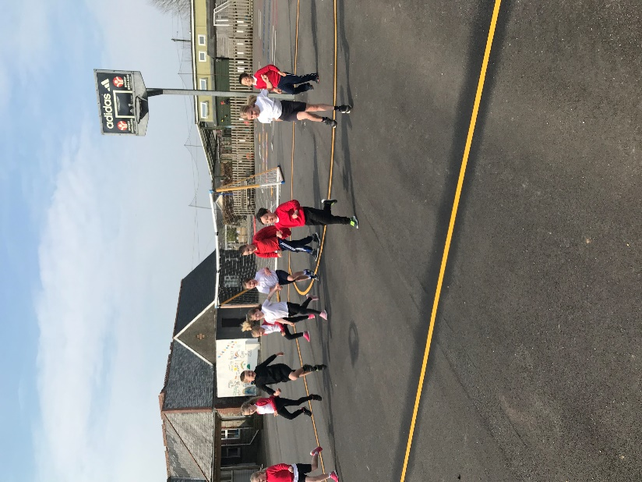

In the second half of the Summer term we ran a tennis club after school which was well attended.
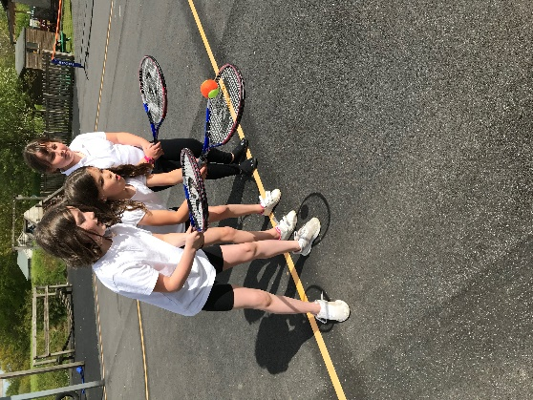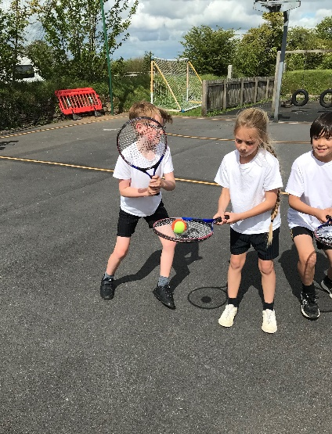

We ended the end of the Summer term with two fantastic sports days with parents watching (Socially distanced!!)
Cornwall Cricket once again continued their association with the school and provided 6 weeks of superb coaching to the Wrens and Puffins classes.
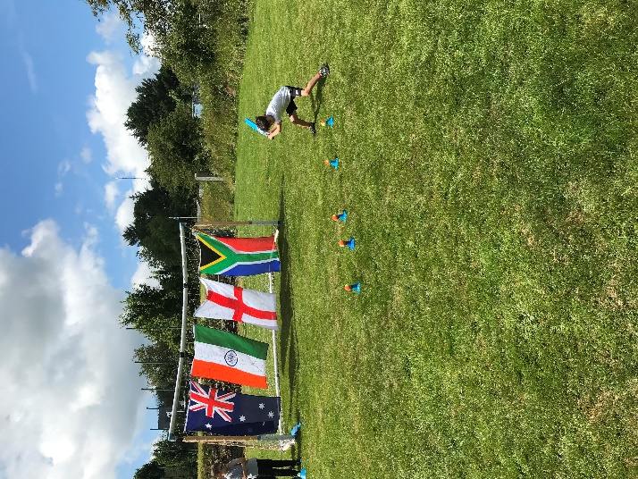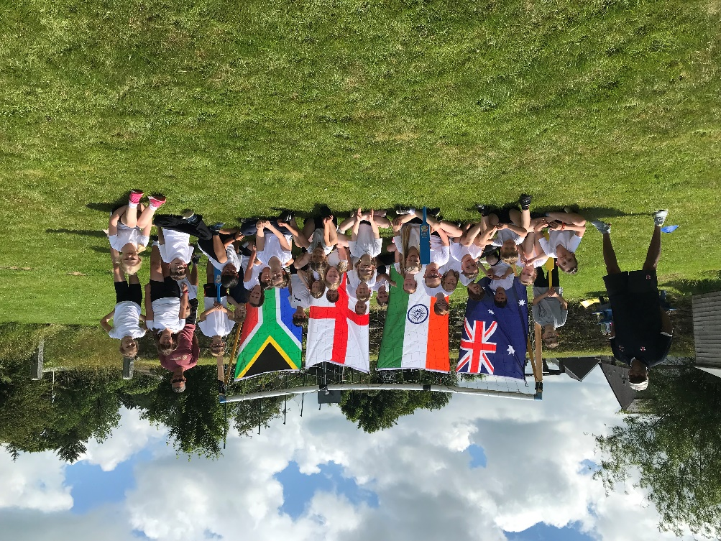
Classes took on Orienteering challenges and showed great teamwork and decision skills.
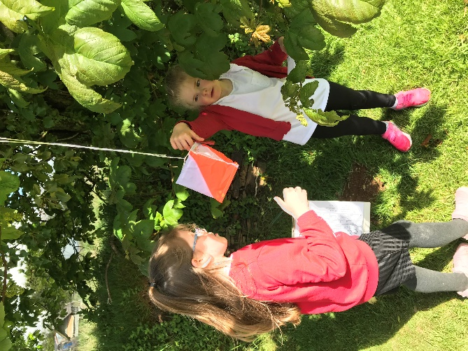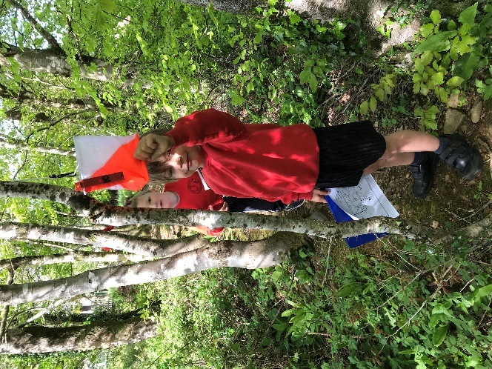

We made the most of the fine weather for Athletics and running activities on the wonderful grounds.
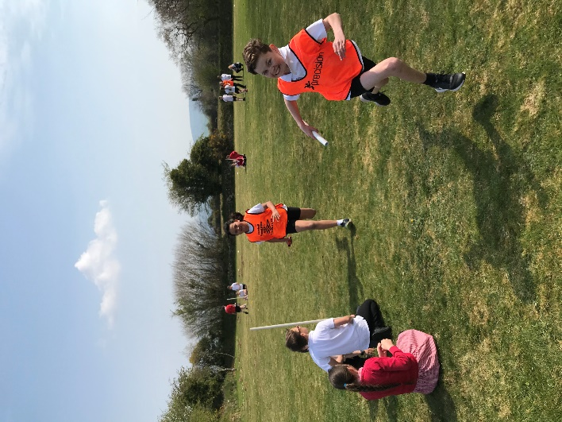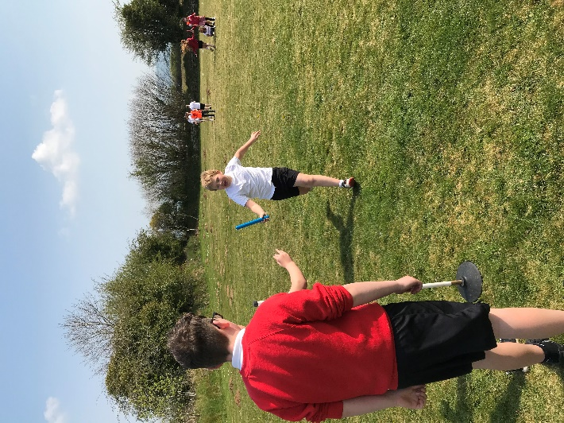
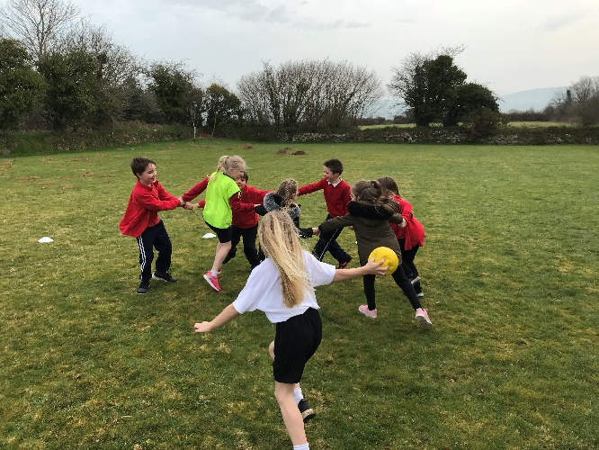
Bikeability has been on offer for the Year 6 in the school with road awareness skills and riding around the streets of Pensilva safely.
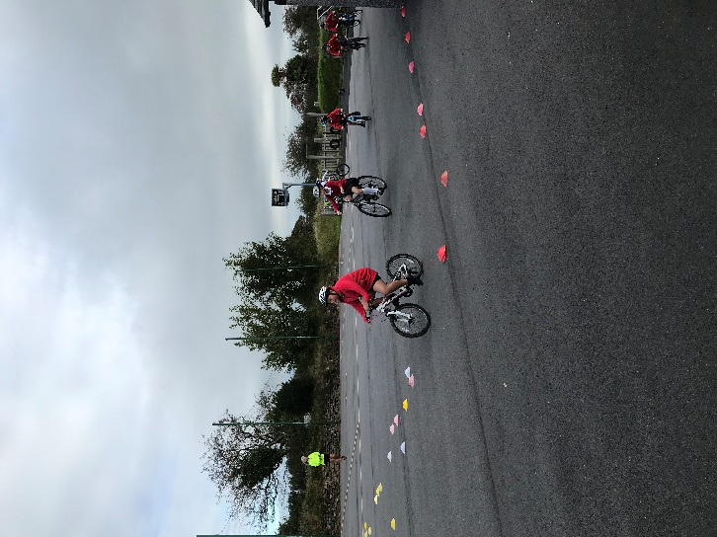
Despite the weather being mixed classes have had a lot of outside activity from learning Handball to focusing on Fundamental skills.
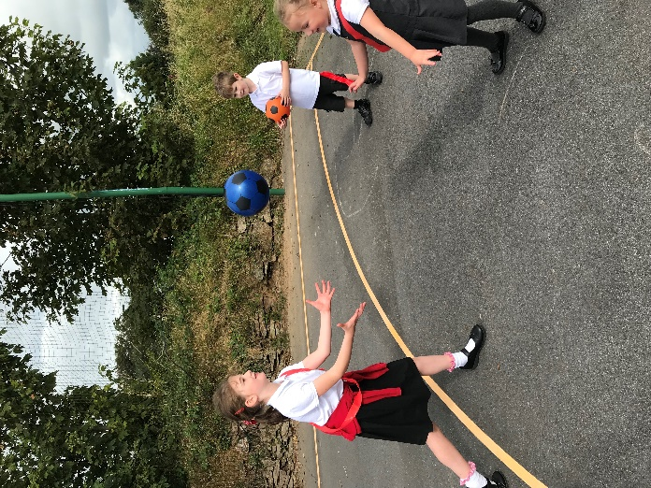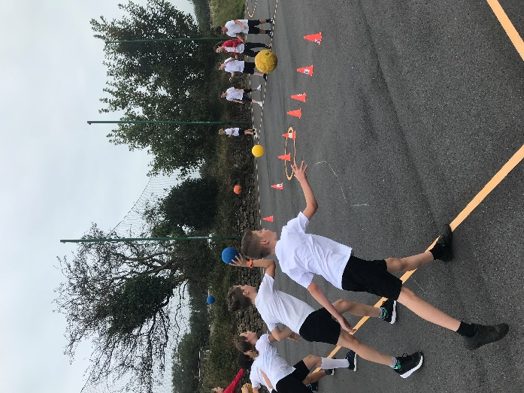
When indoors there has been fitness sessions, team games and more fun!
