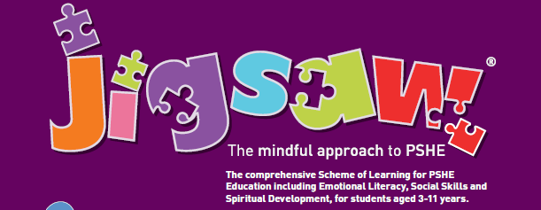

Dear Parents/Carers

PSHE Education (Personal, Social, Health and Economic Education) is a planned programme of learning through which children and young people acquire the knowledge, understanding and skills they need to successfully manage their lives – now and in the future. As part of a whole-school approach, PSHE Education develops the qualities and attributes pupils need to thrive as individuals, family members and members of society.

Jigsaw is a whole-school approach and embodies a positive philosophy and creative teaching and learning activities to nurture children’s development as compassionate and well-rounded human beings as well as building their capacity to learn.

Jigsaw has two main aims for all children:

* To build their capacity for learning
* To equip them for life

Jigsaw brings together PSHE Education, compulsory Relationships and Health Education, emotional literacy, mindfulness, social skills, and spiritual development.

All year groups work on the same theme (Puzzle) at the same time at their own level. There are six Puzzles (half-term units of work) and each year group is taught one lesson per week. Each Puzzle starts with an introductory assembly, generating a whole school focus for adults and children alike. There is also a Weekly Celebration that highlights a theme from that week’s lesson across the school encouraging children to deepen their understanding and embrace the learning focus in their behaviour and attitudes.

The overview below summarises the content in each of Jigsaw’s units of work (Puzzles):

**Being Me in My World** covers a wide range of topics, including a sense of belonging, welcoming others and being part of a school community, a wider community, and a global community; it also looks at children’s rights and responsibilities, working and socialising with others, and of pupil voice.

**Celebrating Difference** focuses on similarities and differences and teaches about diversity, such as disability, racism, power, friendships, and conflict; children learn to accept everyone’s right to ‘difference’, and most year groups explore the concept of ’normality’. Anti-bulling, including cyber bulling, is an important aspect of this Puzzle.

**Dreams and Goals** aims to help children think about their hopes and dreams, their goals for success, what their personal strengths are, and how to overcome challenges, using teamwork, skills, and tasks. There is also a focus on enterprise and fundraising. Children learn about experiencing and managing feelings of pride, ambition, disappointment, and success. They get to share their aspirations, dreams, and goals of others in different cultures/countries, and their dreams for their community and the world.

**Healthy Me** covers two main areas of health: Emotional/mental health (relaxation, being safe, friendships, mental health skills, body image, relationships with food, managing stress) and Physical Health (eating a balanced diet, physical activity, rest, and relaxation, keeping clean, being safe, first aid).

**Relaxation** starts with building a respectful relationship with self and covers topics including families, friendships, pets and animals, and love and loss. A vital part of this Puzzle is about safeguarding and keeping children safe, this links to online safety and social networking. Children learn how to deal with conflict, build skills in assertiveness, and identify their own strengths and strategies for building self-esteem and resilience.

**Changing Me** deals with change of many types. Growing from young to old, becoming a teenager, assertiveness, puberty, self-respect and safeguarding. Each year group thinks about looking ahead, moving year groups or the transition to secondary school and how to cope positively with such changes.

The children are really enjoying their PSHE lessons. If you have any further questions, please contact me (bpalfrey@pensilva.cornwall.sch.uk)

Yours sincerely

Becky Palfrey (Puffin Class Teacher)

Science, PSHE, RE Lead.