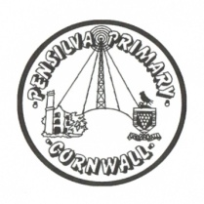
Puffin Class Home-School Communication Sheet
Week beginning Monday 5th July 2021.
School Dinner Week 3

This week’s diary |  | Wow! What an amazing sports day! I am extremely proud of Puffin Class. What an amazing team effort, well done!  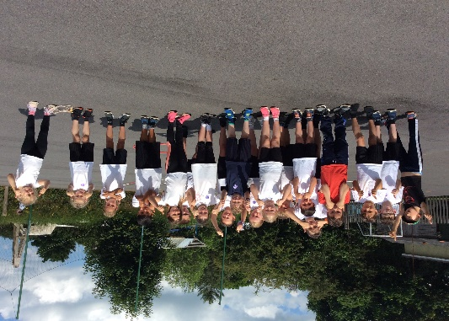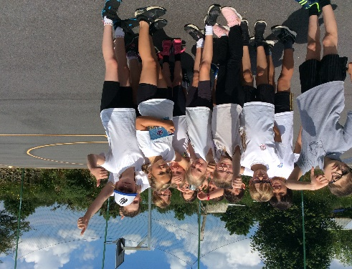  This week we have been researching the history of the Olympic games. We looked at a variety of Olympic mascots for the summer and winter Olympics. The children then had a go at designing their own and labelling its features.  In geography we have been developing our map reading skills and learning how to read direction on maps using the eight points of the compass.  Please can you make sure children have a full, named PE kit in school. (Tuesday and Wednesday)  Homework has been set on mathletics.com and spag.com and logins for these sites are in the children’s reading records. We have also sent home all of the logins on a piece of card. Please make sure you also challenge yourself on Times Table Rockstars.  Spellings will be sent home on Monday to learn for a spelling test on Friday.
Monday | Mrs Palfrey  Library books
Tuesday | Mrs Palfrey  PE
Wednesday | Mrs Palfrey  PE with Mr Jones.  PPA Cover (p.m.) Mrs McDowell
Thursday | Mrs Palfrey
Friday | Mrs Palfrey  Spelling Test | Upcoming dates  - Thursday 22nd July – last day of term.
Other information
Please feel free to send me an email if you have any questions or concerns. bpalfrey@pensilva.cornwall.sch.uk
Do not forget the school website for information on school events, policies and newsletters. http://pensilva.eschools.co.uk/website or our Facebook page

