Key Instant Recall Facts
Year 5 - Autumn term 2.
I know what a prime number is
I can name the prime numbers to 100.

What are prime numbers?
A prime number is a number that can only be divided by itself and 1.
For example 5 is a prime number because it can only be divided by 5 and 1.
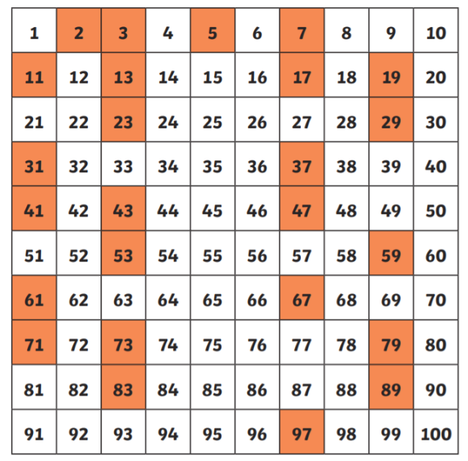
Here are all the prime numbers to 100.

Patterns to notice:
- They never end in 5 or 2 (apart from 5 and 2)
- They are never an even number (apart from 2)

How you can help at home. Practise these prime numbers at home as often as you can – even 5 minutes a night will make a massive difference



