PE Report Spring Term 2016
The term started actively with PE lessons in the hall. The sessions were a range of fitness exercises mixing cardio-vascular and muscular and children rotated from one exercise to another after a minute. Exercises included mini-trampolining, speed bounces, press-ups, agility ladders and many more! Fitness levels definitely improved throughout the half term.
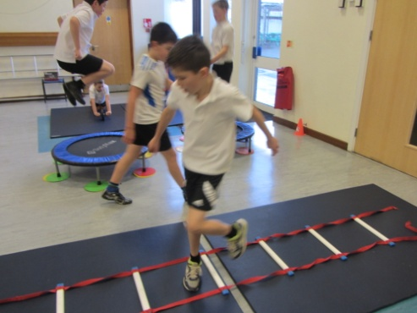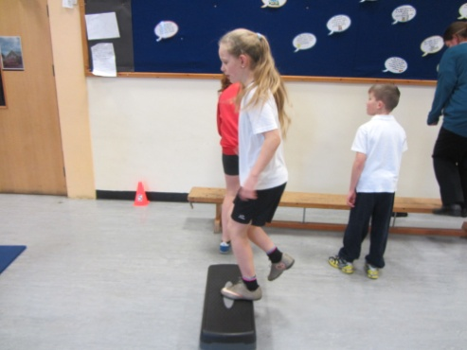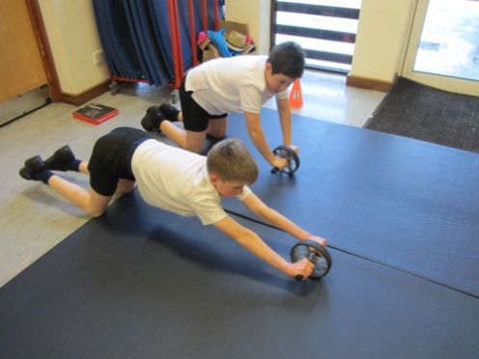
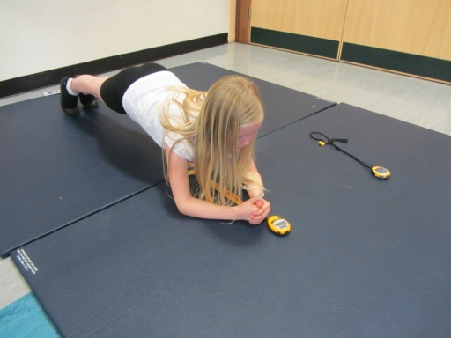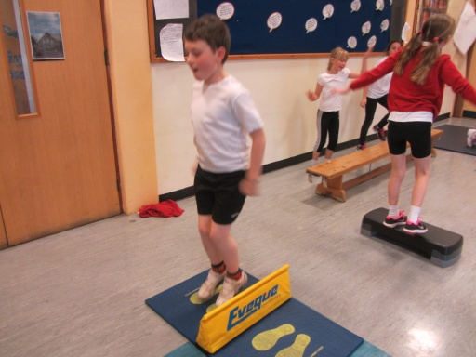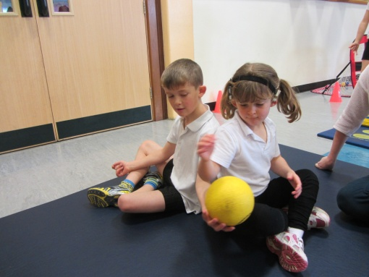
Other sessions include uni-hockey on the rare occasions we can get outside in dry conditions! The children learn the skills of invasion games, looking for space, passing and playing competitive matches.
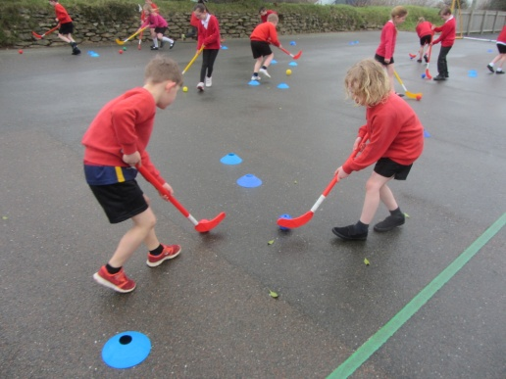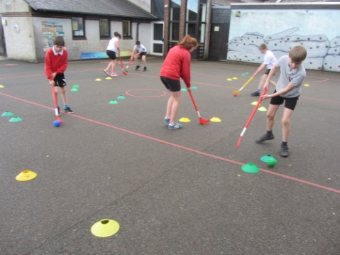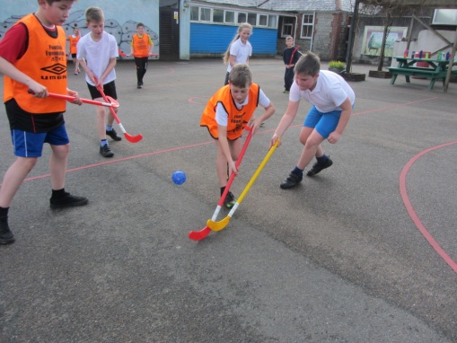

This term KS2 have competed in the local Netball League and the football league. In the football against St Neot, Harrowbarrow and Gunnislake they showed great determination and sportsmanship.
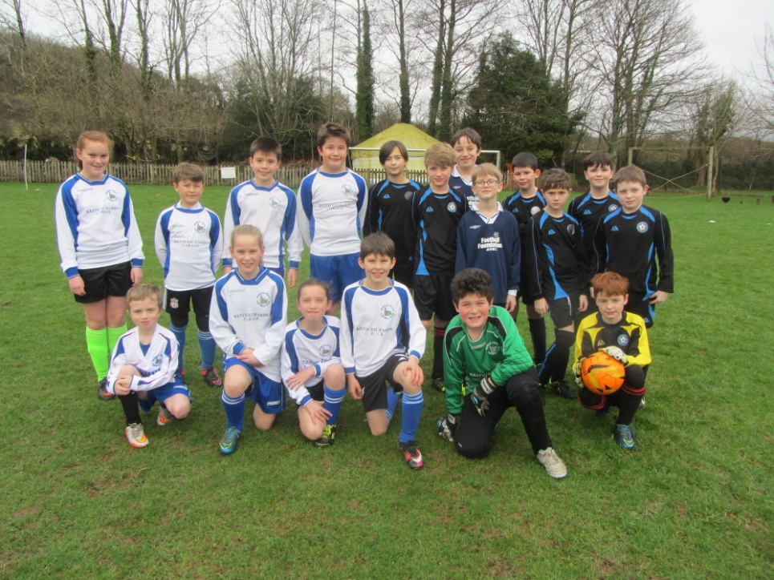
We also fielded a team of tag rugby players who travelled to Quethiock to compete in a match. Pensilva won 5-4!
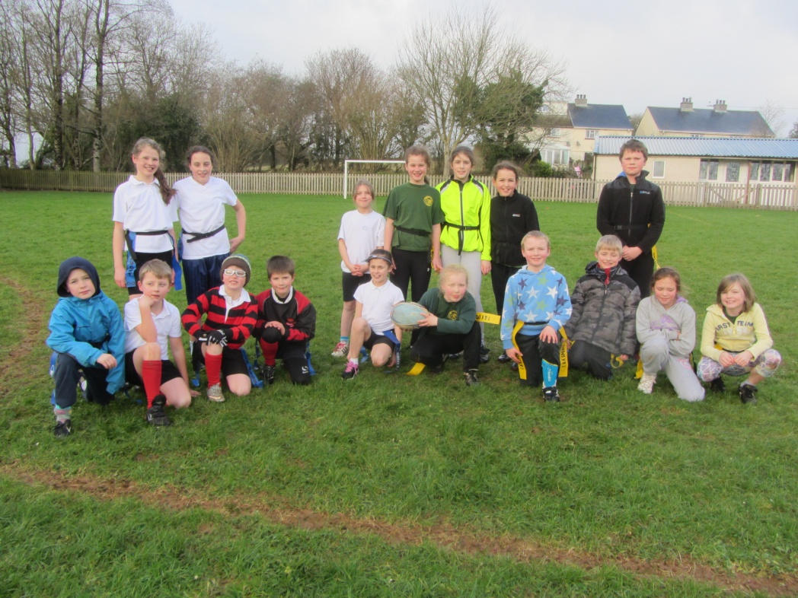

Football club seems as popular as ever with lots of girls taking part. A really talented and upcoming team in the making!
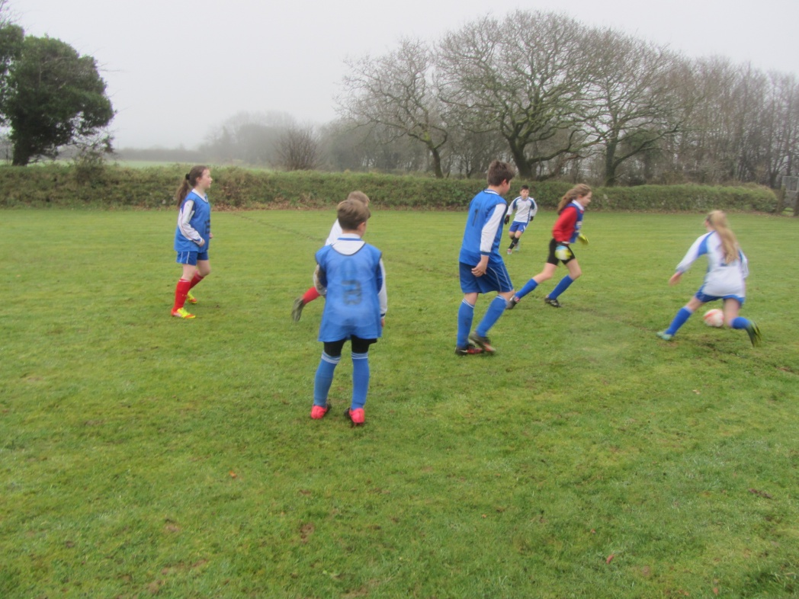
Sports leaders are continuing their lunchtime sessions for the infants and providing fun and active games. Well done!!
Pensilva continue to excel in the local monthly sporting challenges: activities for break times and lunchtimes. Results are collated and compared with other schools. Sports leaders from Yr 6 organise and officiate the activities and email the results off. This month in March the challenge is a rugby run for 1 minute. Good luck!!
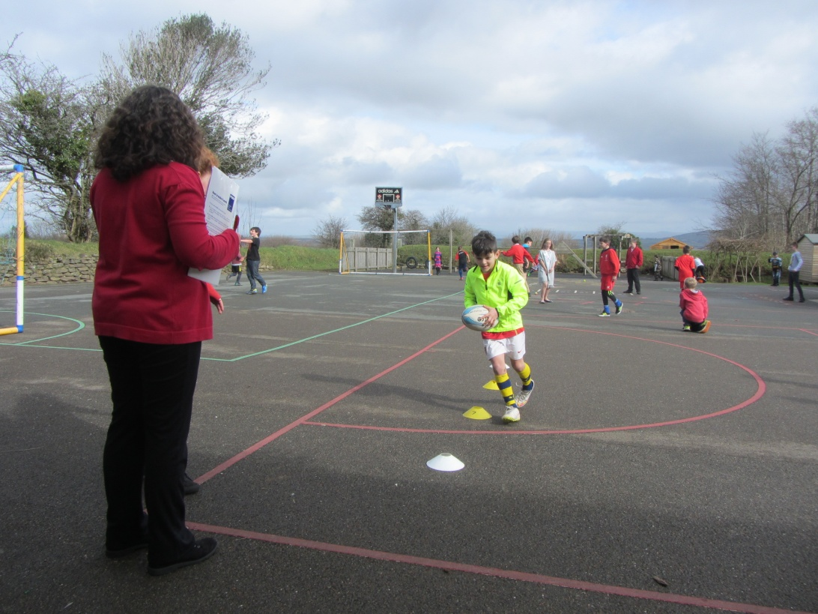
Cross Country Club has had a brilliant season with every child putting in 100% effort. Some notable league races obviously highlighted by Tyler’s amazing 5 wins out of 5 races!!! Thanks to Lucy Thomas for delivering the training!
In the interest of staff development and CPD, Mr Jones is preparing an indoor circuits box with resource cards and equipment including agility ladders. Staff training in how to utilise the resources will offer further opportunities for the children.
Easter Hunt- Mr Jones organised an orienteering Easter hunt where children had to search out clues using the school grounds.
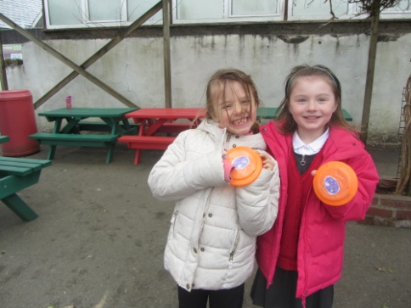
When the weather was poor Benchball was a popular activity in the hall involving throwing, catching and teamwork!
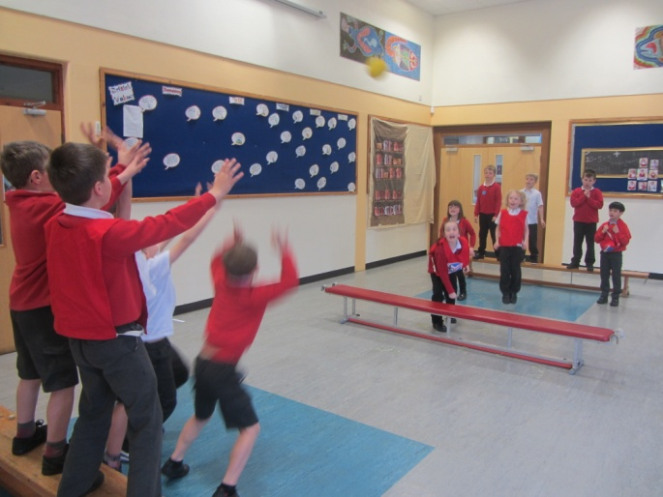
Landrake Run- Tyler Gregory was the first boy in the history of the school to win the annual Landrake run, competing against 600 pupils.
