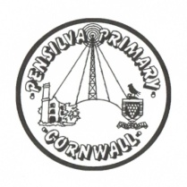
Puffin Class Home-School Communication Sheet
Week beginning Monday 16th May 2022.
School Dinner Week 2

This week’s diary |  | A superb week Puffin Class!  This week in science we have been classifying invertebrates. Invertebrates do not have a backbone, or a skeleton made of bones. Many have a hard shell outside their bodies to protect them. Others have soft, flexible bodies. More than 80% of living things on the planet, and 98% of animals, are invertebrates. A specimen is a particular plant or animal that scientist’s study to find out about its species. We have been looking for specimens of invertebrates in and around our school grounds. It was amazing how many invertebrates we found, we had to look in grass, trees, under logs, stones, leaves. We used a magnifying glass to look closely at its characteristics.  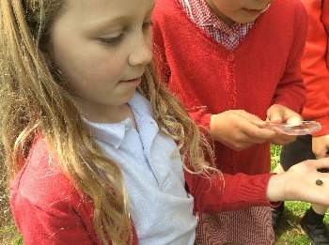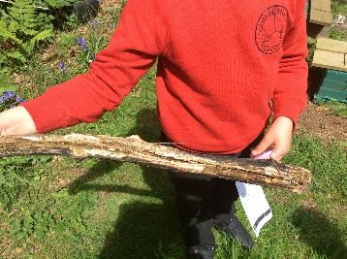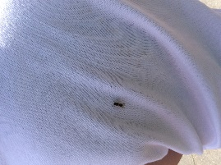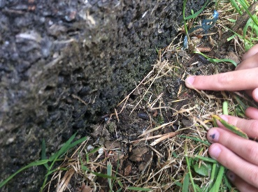  Please can you make sure you listen to your child read and ask them questions about the story. Please remember to sign their reading record. Once you have finished reading a book, my comprehension group will complete a REN test to see if they have understood what they have read.  Please can you make sure children have a full, named PE kit in school. (Thursday and Friday)  Homework  Homework will be set on a Friday and handed in the following Friday.  Spellings and times tables will be given on a Friday to learn for a spelling and times tables test the following Friday.  Please encourage your child challenge themselves on Times Table Rockstars and Mathletics.  Library books can be chosen and taken home on a Monday.
Monday | Mrs Palfrey  Library books  Mrs Harris/Miss Treleaven (a.m.)  Mrs Olver (p.m.)
Tuesday | Mrs Palfrey  Mrs Harris/Miss Treleaven (a.m.)  Mrs Olver (p.m.)
Wednesday | Mrs Palfrey  Mrs Harris/Miss Treleaven (a.m.)  Mrs Olver (p.m.)
Thursday | Mrs Palfrey  Mrs/Harris/Miss Treleaven (a.m.)  PE with Mr Jones.  PPA Cover (p.m.) Mrs McDowell  Mrs Olver
Friday | Mrs Palfrey  Miss Treleaven  PE  Spelling/times table test | Upcoming dates  Tuesday 22nd May – Class photographs.
Other information
Please feel free to send me an email if you have any questions or concerns. bpalfrey@pensilva.cornwall.sch.uk
Do not forget the school website for information on school events, policies and newsletters. http://pensilva.eschools.co.uk/website or our Facebook page

