Puffin Class Home-School Communication Sheet
Week beginning Monday 23rd May 2022.
School Dinner Week 3

This week’s diary |  | Week 4 of our swimming sessions!  We have been swimming for the past few weeks and it has been wonderful to see them challenge themselves and some to even outcome their fears! We have had some amazing comments about how sensible, polite and well-mannered children from Pensilva are. Well done and we are extremely proud of you all.  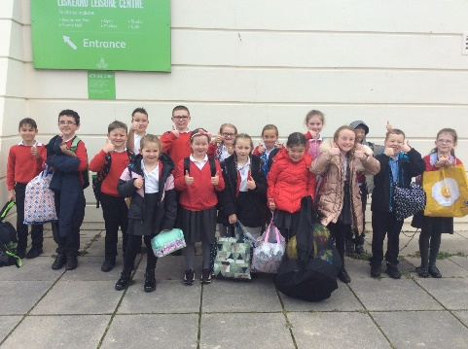  Please can you make sure you listen to your child read and ask them questions about the story. Please remember to sign their reading record. Once you have finished reading a book, my comprehension group will complete a REN test to see if they have understood what they have read.  Please can you make sure children have a full, named PE kit in school. (Thursday and Friday)  Homework  Homework will be set on a Friday and handed in the following Friday.  Spellings and times tables will be given on a Friday to learn for a spelling and times tables test the following Friday.  Please encourage your child challenge themselves on Times Table Rockstars and Mathletics.  Library books can be chosen and taken home on a Monday.
Monday | Mrs Palfrey  Library books  Mrs Harris/Miss Treleaven (a.m.)  Mrs Olver (p.m.)
Tuesday | Mrs Palfrey  Mrs Harris/Miss Treleaven (a.m.)  Mrs Olver (p.m.)
Wednesday | Mrs Palfrey  Mrs Harris/Miss Treleaven (a.m.)  Mrs Olver (p.m.)
Thursday | Mrs Palfrey  Mrs/Harris/Miss Treleaven (a.m.)  PE with Mr Jones.  PPA Cover (p.m.) Mrs McDowell  Mrs Olver
Friday | Mrs Palfrey  Miss Treleaven  PE  Spelling/times table test | Upcoming dates  Tuesday 22nd May – Class photographs.  The whole school will be taking part in Jubilee celebrations on Friday 27th May. Children can come to school dressed in non-school uniform and the theme is red, white and blue! We will be having a ‘street party’ in the afternoon and we would like children to bring in food donations for all the children to share (enough for approx. 6 children).  Puffin Class – Sweet donations.
Other information
Please feel free to send me an email if you have any questions or concerns. bpalfrey@pensilva.cornwall.sch.uk
Do not forget the school website for information on school events, policies and newsletters. http://pensilva.eschools.co.uk/website or our Facebook page

