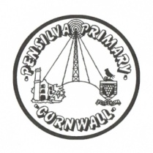
Puffin Class Home-School Communication Sheet
Week beginning Monday 22nd November 2021.
School Dinner Week 1

This week’s diary |  | Super work Puffin Class.  In history we have been learning about Tudor England and Henry VIII, we focused on his six wives and why he was so desperate for an heir.  In maths we have been learning how to solve reasoning and problem-solving tasks linked to our KIRFS (Key Instant Recall Facts)  In science we have continued to learn about the human digestive system. We then had a go at explaining the function of each organ in the digestive system.  In PE we have been focusing on different types of jumps. We have been using a variety of apparatus to do this including benches, low boxes and springboards. We also had a go at balancing on the large apparatus. It has been great fun!  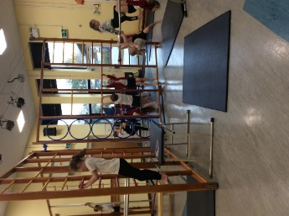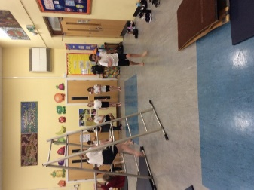  The children have really enjoyed the different activities this week to raise money for Children in Need. Thank you to all those who have contributed.  Please can you make sure you listen to your child read and ask them questions about the story. Please remember to sign their reading record. Once you have finished reading a book, my comprehension group will complete a REN test to see if they have understood what they have read.  Please can you make sure children have a full, named PE kit in school. (Thursday and Friday)  Homework  Homework will be set on a Friday and handed in the following Friday.  Spellings and times tables will be given on a Friday to learn for a spelling and times tables test the following Friday.  Please encourage your child challenge themselves on Times Table Rockstars and Mathletics.  Library books can be chosen and taken home on a Monday.
Monday | Mrs Palfrey  Library books  Mrs Harris
Tuesday | Mrs Palfrey  Mrs Harris
Wednesday | Mrs Palfrey  Mrs Harris
Thursday | Mrs Palfrey  PE with Mr Jones.  PPA Cover (p.m.) Mrs McDowell  Mrs Harris
Friday | Mrs Palfrey  Mrs Harris  PE  Spelling/times table test | Upcoming dates  - Wren and Dove class trip to the theatre (Wednesday 8th December)  - Christmas jumper day, £1 donation non-school uniform (Friday 10th December)  - Christmas lunch (Wednesday 15th December)  - Mufti day £1 donation to raise money for the PSA. (Friday 17th December)
Other information
Please feel free to send me an email if you have any questions or concerns. bpalfrey@pensilva.cornwall.sch.uk
Do not forget the school website for information on school events, policies and newsletters. http://pensilva.eschools.co.uk/website or our Facebook page

