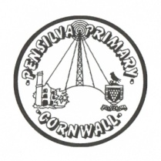
Puffin Class Home-School Communication Sheet
Week beginning Monday 26th April 2021.
School Dinner Week 3

This week’s diary |  | What a wonderful week to be back at school with this glorious weather!  In English this week, year 3 and 4 have been reading, performing and creating our own poems.  Year 2 have been reviewing skills used in English and joining their handwriting.  In maths, year 3 and 4 have focused on reading and writing the time on analogue and digital 24-hour clocks, as well as looking at different measures of time and the relationships between them.  Year 2 have revising number bonds to 10 and 20.  In Science, year 3 and 4 have started a new unit ‘States of Matter’ we have classified materials as a solid, liquid or gas.  Year 2 have been identifying the different uses of everyday materials.  In topic, we have been learning about Ancient Egypt, we looked at a variety of artefacts to help us find out more about how the ancient Egyptians used to live.  We have loved participating in Forest School and tennis this week.  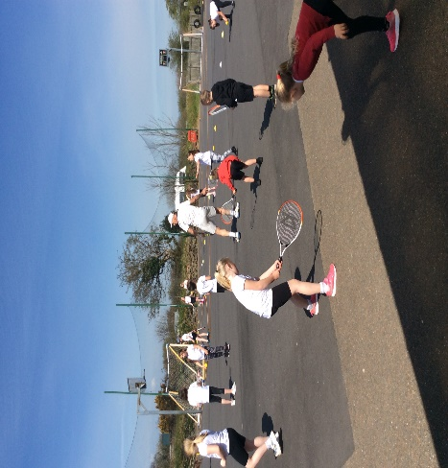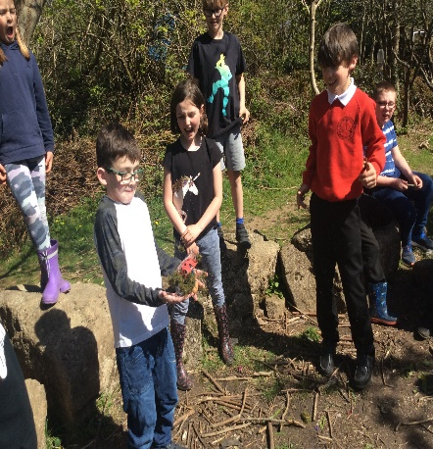  Please can you make sure children have a full, named PE kit in school. (Tuesday and Wednesday)  A spare set of clothes and shoes for Forest School (Thursday)  Homework has been set on mathletics.com and spag.com and logins for these sites are in the children’s reading records.  Spellings will be sent home on Monday to learn for a spelling test on Friday.
Monday | Mrs Palfrey  Library books
Tuesday | Mrs Palfrey  Tennis coaching
Wednesday | Mrs Palfrey  PE with Mr Jones.  PPA Cover (p.m.) Mrs McDowell
Thursday | Mrs Palfrey  Forest School
Friday | Mrs Palfrey | Upcoming dates  - Bank holiday – Monday 3rd May
Other information
Please feel free to send me an email if you have any questions or concerns. b.palfrey@pensilva.cornwall.sch.uk
Do not forget the school website for information on school events, policies and newsletters. http://pensilva.eschools.co.uk/website or our Facebook page

