Key Instant Recall Facts
Reception - Autumn term 1.
I can name numbers in order to 10.
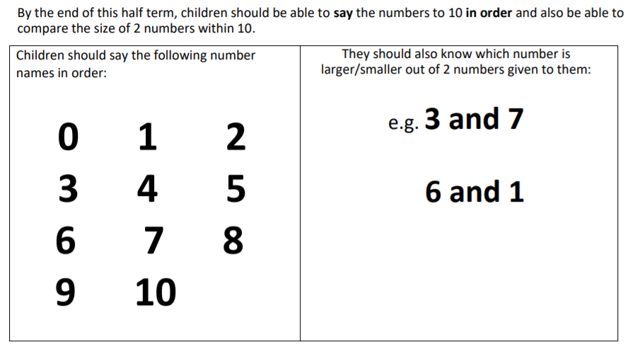
I can say which number is bigger or smaller.
Ways to help at home – practise counting little and often. In the car on the way home, when climbing up some stairs or when playing with toys or teddies.
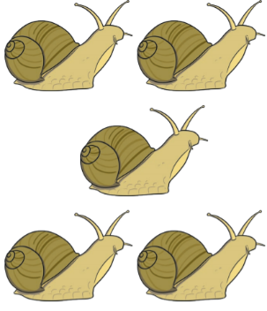
How many snails can you count?
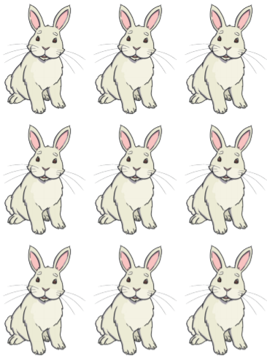

How many rabbits can you count?

