Key Instant Recall Facts
Year 3 - Autumn term 2.
I can count in 3s.
I know multiplication and division facts for the 3 times tables.
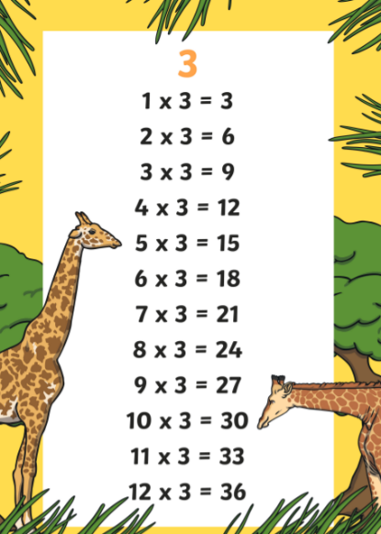
By the end of the term your child should know multiplication and division facts for the 3 times table.

Once your child is confident knowing the multiplication tables they can start to use this to do the divisions – for example “3 x 2 = 6 therefore 6 ÷ 2 = 3”

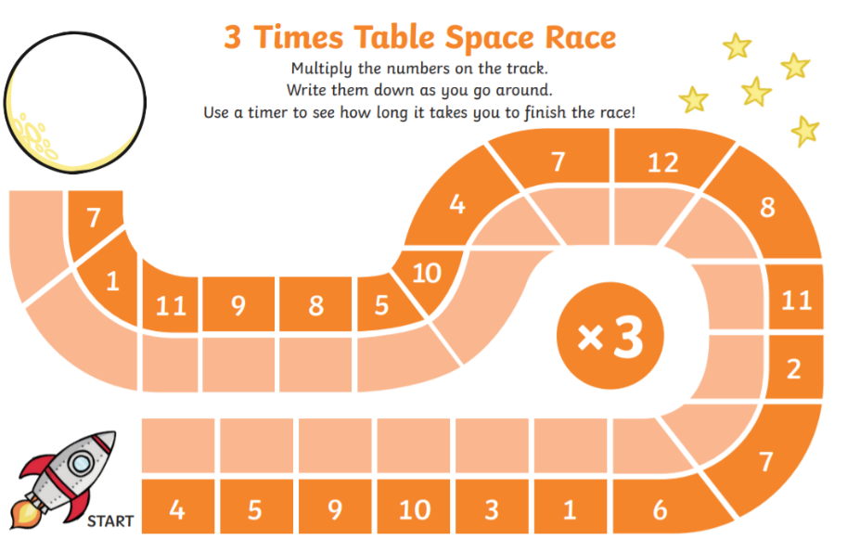
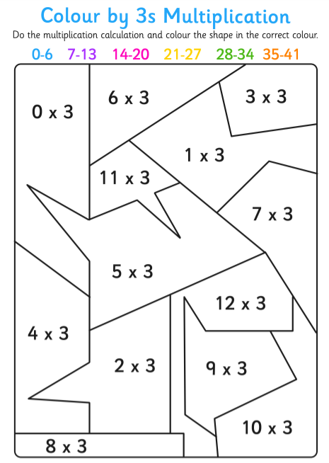
How you can help at home – remember that a little and often approach is best. Practise the 3 times tables in the car, on the way home from school, in the bath, waiting in a queue or whenever you have a spare moment.
Have a go at these activities to practise.

