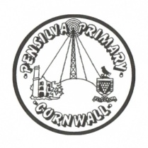
Wren’s Class Home-School Communication Sheet
Week commencing 4th April
School dinner – week 2

This week’s diary |  | Wrens have had a brilliant week this week learning all about The Great Fire of London’ and what life was like for people in 1666.  We have also done some weighing and will be continuing this next week.  On Friday there will be a change of dinner menu – the options are:  Main: steak pasty and chips  Veggie – Quorn burger and chips.  On Friday the school will be doing our Easter performance at 2.00 PM at Millennium House. The children can be collected from here if you are attending the performance.  Friday is also the last day of term.  Children will return to school on Monday 25th April.
Monday | Miss Thomas
Tuesday | Miss Thomas
Wednesday | Miss King
Thursday | Miss King  Mrs McDowell & PE with Mr Jones PM
Friday | Miss King | Upcoming dates:  Friday 8th April – Easter performance and last day of term.  Monday 25th April children return to school.  Monday 2nd May – bank holiday.
Other information
Please feel free to send us an email if you have any questions or concerns: Jthomas@pensilva.cornwall.sch.uk lking@pensilva.cornwall.sch.uk
Do not forget the school website; http://pensilva.eschools.co.uk/website for information on school events, policies and newsletters or our Facebook page; Pensilva Primary School for updates.

