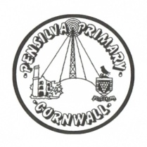
Puffin Class Home-School Communication Sheet
Week beginning Monday 10th May 2021.
School Dinner Week 2

This week’s diary |  | Puffin Class have shown resilience this week!  In English this week, year 3 and 4 have been reading The Hodgeheg by Dick King-Smith. We have also been researching lots of interesting facts about hedgehogs.  Year 2 have been learning the poem: The Owl and the Pussy-cat. They have also had fun changing some of the words for their own "nonsense" ideas. When writing up the poems, the children have been focussing on handwriting and most are now beginning to join up.  In maths, year 3 and 4 have been classifying equilateral, isosceles and scalene triangles. We have also had a go at calculating missing angles in a triangle.  Year 2 have continued to explore measurement with a focus on cm and m. We finished this topic area on Friday and the children had a range of problems to solve. They could choose from easier ones, average difficulty, or harder problems according to their ability and confidence. We are working hard to become more independent and resilient in our learning, ready for Key Stage 2!  In Science, year 3 and 4 have focused on melting. We carried out an investigation to observe how fast chocolate would melt if we change the temperature of the water.  Year 2 planned and carried out an investigation to observe which type of paper is the most absorbent.  In topic, we have been learning how the ancient Egyptians prepared the body for mummification.  Puffin Class had an amazing time this week taking part in Forest School. They were learning about fire safety and had a go at carefully toasting marshmallows over an open fire. They even found time to paint their bug hotel.  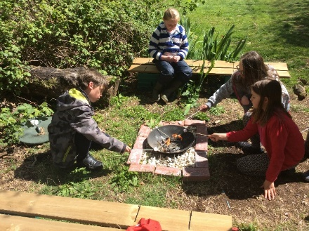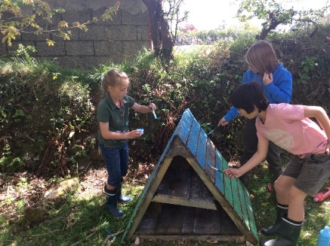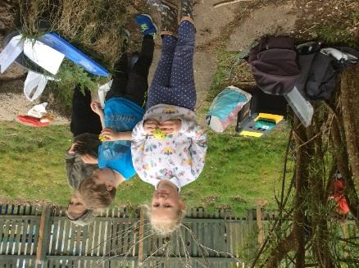  Please can you make sure children have a full, named PE kit in school. (Tuesday and Wednesday)  A spare set of clothes and shoes for Forest School (Thursday)  Homework has been set on mathletics.com and spag.com and logins for these sites are in the children’s reading records. Please make sure you also challenge yourself on Times Table Rockstars.  Spellings will be sent home on Monday to learn for a spelling test on Friday.
Monday | Mrs Palfrey  Library books
Tuesday | Mrs Palfrey  Tennis coaching
Wednesday | Mrs Palfrey  PE with Mr Jones.  PPA Cover (p.m.) Mrs McDowell
Thursday | Mrs Palfrey  Forest School
Friday | Mrs Palfrey | Upcoming dates  - Parent Consultations – Monday 10th May, Tuesday 11th May.
Other information
Please feel free to send me an email if you have any questions or concerns. bpalfrey@pensilva.cornwall.sch.uk
Do not forget the school website for information on school events, policies and newsletters. http://pensilva.eschools.co.uk/website or our Facebook page

