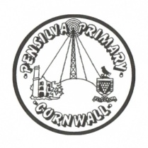
Puffin Class Home-School Communication Sheet
Week beginning Monday 21st June 2021.
School Dinner Week 1

This week’s diary |  | Super Swimmers!  Year 3 and 4 have been swimming this week and it has been wonderful to see them challenge themselves and some to even outcome their fears! We have had some amazing comments about how sensible, polite and well-mannered children from Pensilva are. Well done and we are extremely proud of you all.  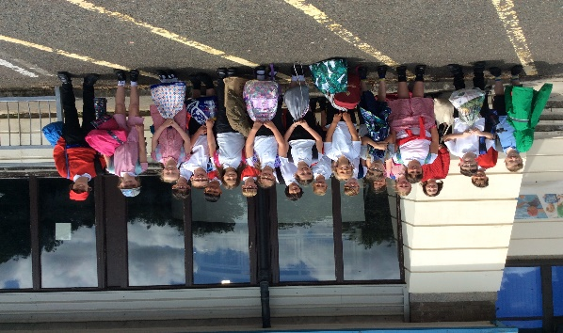  Year 2 have started their new science topic ‘Living things and their habitats.’ They have enjoyed comparing things that are living, dead and have never been alive. They have also explored our outside habitat to see what living things they could find.  Please can you make sure children have a full, named PE kit in school. (Tuesday and Wednesday)  Homework has been set on mathletics.com and spag.com and logins for these sites are in the children’s reading records. We have also sent home all of the logins on a piece of card. Please make sure you also challenge yourself on Times Table Rockstars.  Spellings will be sent home on Monday to learn for a spelling test on Friday.
Monday | Mrs Palfrey  Library books
Tuesday | Mrs Palfrey  PE
Wednesday | Mrs Palfrey  PE with Mr Jones.  PPA Cover (p.m.) Mrs McDowell
Thursday | Mrs Palfrey
Friday | Mrs Palfrey  Spelling Test | Upcoming dates  - Sports day Wednesday 30th June
Other information
Please feel free to send me an email if you have any questions or concerns. bpalfrey@pensilva.cornwall.sch.uk
Do not forget the school website for information on school events, policies and newsletters. http://pensilva.eschools.co.uk/website or our Facebook page

