Daymer and Polzeath Children Home Learning w/c 15/6/2020
Hi everyone, hope you had a good week last week. We’re going to follow the river Tiddy from the moors and see where it flows to.
I’m really looking forward to being able to have a chat with the Daymer children on Tuesday and Miss Holt has really enjoyed the chats she’s been having. If you haven’t replied to the emails about the phone calls and your child would like one then please let us know via our email addresses below.
jthomas@pensilva.cornwall.sch.uk or vholt@pensilva.cornwall.sch.uk

- PHONICS – Hopefully this has been the one area you have focussed on throughout lockdown. The children need to confidently recognise and know the sound and name of the following phonemes (letters), digraphs (two letter sounds) and trigraphs (three letter sounds). Phase 4 does not have sounds.
Phase 2 – s, a, t, p, i, n, m, d, g, o, c, k, ck, e, u, r, h, b, f, ff, l, ll, ss
Phase 3 – j, v, w, x, y, z, zz, qu, ch, sh, th, ng, ai, ee, igh, oa, oo, oo, ar, or, ur, ow, oi, ear, air, ure, er
Phase 5 - ay, ou, ie, ea, oy, ir, ue, aw, wh, ph, ew, oe, au, ey, a-e, e-e, i-e, o-e, u-e
Please continue to work through these sounds and ensure your child is confident enough to see them in the words they are reading and are beginning to remember them when they write. Please keep working through the Key Words, once they can read them all please help them to learn to spell them confidently. I have attached another copy of the words for you to work through.
If you feel your child has completed these sounds please contact me separately and I will email out some more activities.

- WRITING/ENGLISH –
This week I would like the children to do their writing through cross curricular links to geography. We are going to explore the river Tiddy. Where does it start? Where does it end? Which river does it join? Which villages does it flow through?
I would like to you to do some research about rivers. Please use the website https://www.theschoolrun.com/homework-help/rivers to help This attached as a link too. I have attached a fact file sheet for the children to print off and complete. If you do not have access to a printer you can create your own fact file sheet using the same questions.
After you have researched rivers and completed the fact file sheet about rivers I would like the children to draw a picture of the river Tiddy and label the different parts e.g the source, the mouth, tributaries and the villages it flows through. Does the river Tiddy join another river or does it flow straight to the sea? Where does it finally meet the sea?
Once these are completed I would love to see them!!
Polzeath –
This week we will do our English through a Geography topic. The topic is Where are our seasides ? and we will focus on LOOE as many of you will have been there many times!
On the home learning site is a PowerPoint covering the learning for the week but broken down into days. There are also some extra resources such as writing frames on the site. If you cannot access it as a PowerPoint on your device then it is also on the site as PDF . If you use the PDF format then on Tuesday you will need to go to BBC bitesize ‘a visit to Poole Harbour’

- Maths –
Year 1 and 2children – you will continue to work through the home learning activities attached below. If any Reception children are ready for extending on past the activities planned below please feel free to explore the Year 1 maths – just be aware this will be a lot harder and more formal than they are used to.

Daymer children we are going to focus on number ordering and number value. The children need to confidently count to 100. They need to be able to order numbers to 20 and then 50, when confident also to understand which number is bigger. This can often lead to confusion as the word ‘big’ is associated with physical size. I have attached some sheets to work through. If you cannot print please contact me and I will print them out for collection from school on Tuesday or spend time discussing which number is the largest and ordering them. Write numbers to 20 on paper and cut them out so the children can move them around and order them. To help them understand which number is biggest show them with counters e.g. 6 pieces of pasta compared to 12 pieces of pasta. Children can easily see and begin to understand 12 is the biggest number. You choose two numbers and ask your child to work out which number is biggest/smallest.

- READING - Please continue to read a couple of pages of their reading book or online books using the book band you were told. http://www.oxfordowl.co.uk

- PHYSICAL DEVELOPMENT – if you are able to get to a river/beach, go for a paddle/swim (stay safe and only go with an adult)

- Understanding the world and Expressive art and design / Science, Art, Dt, Geography

Daymer - This week I would like the children to create a river!! They can use mud/sand/junk modelling – water bottles/play dough/drainpipes – anything!! The min focus will be for children to understand the water will only flow downhill. They can put different routes in and see where most of the water goes etc. please take a video clip and send in if you can.
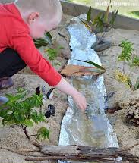
Polzeath and Daymer - ART - using any style you like, could you create a picture of a harbour. There are lots and lots of artists who do this and you may wish to look at some ideas online to get you started
Here are some examples to get you going!

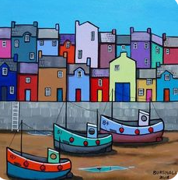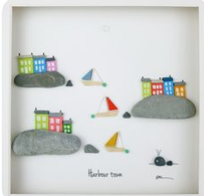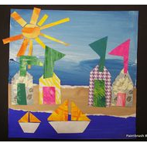

Polzeath and Daymer - SCIENCE- Wave Bottles!
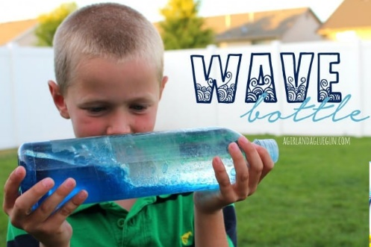

You just need a clear bottle, white vinegar (or water), colouring, and oil
(baby, or vegetable oil)
fill bottle with 1/3 vinegar and add colouring.
Then add oil.
Oil sits up top and won’t mix!
Then swirl—It’s really fun to watch…

This would be great for a “calm down” activity. or a great sensory activity. You can even put sea shells, glitter, or small items inside and watch them ride the waves!

Hopefully this will be a fun week! Please remember, get in touch with either of us if you have any questions. We absolutely love seeing your pictures from home and having updates about how your children are getting on so please keep them coming!

Miss Thomas and Miss Holt.

