Puffin Class Home-School Communication Sheet
Week beginning Monday 3rd May 2021.
School Dinner Week 1

This week’s diary |  | Puffin Class have shown a great team spirit this week!  In English this week, year 3 and 4 have been creating our own calligrams and shape poems.  Year 2 have been reviewing their targets and completing SPAG activities.  In maths, year 3 and 4 have been recognising acute, obtuse and right angles. We also explored lines of symmetry in regular 2D shapes.  Year 2 have been using a ruler to measure objects in the classroom.  In Science, year 3 and 4 have focused on gases. We carried out an investigation to prove whether or not a gas has a weight. We weighed a flat cup of lemonade and a fizzy cup of lemonade. To our surprise, the fizzy lemonade weighed more because it contained carbon dioxide gas.  Year 2 have been identifying the different uses of everyday materials.  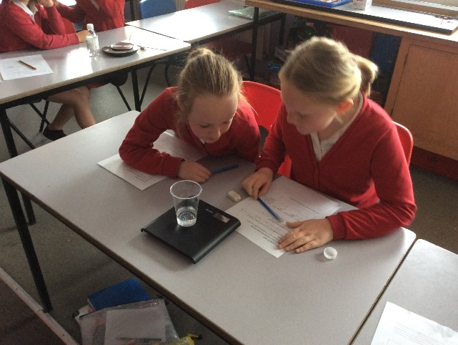  In topic, we have been learning about Ancient Egypt, we looked at how important The River Nile was to the ancient Egyptians.  In art we have been creating collages. We have torn, cut, layered paper in lots of different ways!  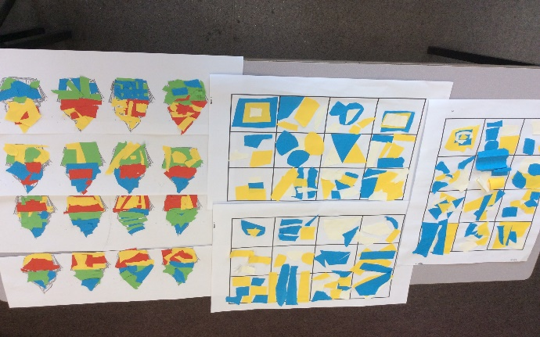  Please can you make sure children have a full, named PE kit in school. (Tuesday and Wednesday)  A spare set of clothes and shoes for Forest School (Thursday)  Homework has been set on mathletics.com and spag.com and logins for these sites are in the children’s reading records.  Spellings will be sent home on Monday to learn for a spelling test on Friday.
Monday | Mrs Palfrey  Library books
Tuesday | Mrs Palfrey  Tennis coaching
Wednesday | Mrs Palfrey  PE with Mr Jones.  PPA Cover (p.m.) Mrs McDowell
Thursday | Mrs Palfrey  Forest School
Friday | Mrs Palfrey | Upcoming dates  - Parent Consultations – Tuesday 4th May, Monday 10th May, Tuesday 11th May.
Other information
Please feel free to send me an email if you have any questions or concerns. b.palfrey@pensilva.cornwall.sch.uk
Do not forget the school website for information on school events, policies and newsletters. http://pensilva.eschools.co.uk/website or our Facebook page

